

**On**

**GYM MANAGEMENT(MY FITNESS)**

Submitted By

Group No. :- 03

**Student Name**: MODI MEET E.no (BCA3341909554)

**Student Name**: VANKAR JIGNESH E.no (BCA3341909597)

Department BCA Semester:-06

Academic Year : 2021-2022

**Internal Guided By External Guided By**

Janak p suthar

Kaveri Mam

**Submitted to**

**Grow More Institution of M.sc(CA&IT),**

**Himatnagar - 383001**

**INDEX**

|  |  |  |
| --- | --- | --- |
| **NO.** | **POINTS** | **PAGES** |
| **01** | **Introduction** | **04** |
| **02** | **Acknowledgement** | **05** |
| **03** | **ABOUT UNIVERSITY** | **06** |
| **04** | **ABOUT INSTITUTE** | **07** |
| **05** | **PROJECT PROFILE** | **08** |
| **06** | **COMPANY`S PROFILE** | **09** |
| **07** | **TECHNICAL SPECIFICATION**  **7.1SOFTWARE SPECIFICATION (Minimum)** | **10-11** |
| **08** | **INTRODUCTION TO SYSTEM DEVELOPMENT**  **TOOLS .NET**  **8.1 Advantages of Asp.NET** | **12-13** |
| **09** | **Bootstrap**  **9.1INTRODUCTION OF DATABASE TOOLS**  **9.2Features of MySQL** | **14-19** |
| **10** | **WAMP** | **20** |
| **11** | **PROJECT DESCRIPTION**  **11.1MANUAL & EXISTING SYSTEM**  **11.2NEED FOR NEW SYSTEM** | **21-22** |
| **12** | **FUNCTIONAL SPECIFICATION**  **12.1Module**  **12.2Module specification** | **23-25** |
| **13** | **USERS OF THE SYSTEM**  **13.1User specification** | **26-27** |
| **14** | **FEASIBILITY STUDY**   1. **Economic Feasibility** 2. **Technical Feasibility** 3. **Operational Feasibility** 4. **Scheduled Feasibility** | **27-30** |
| **15** | **PROJECT TIME SCHEDULING**  **15.1Time line Chart** | **31-32** |
| **16** | **FLOW-CHART** | **33** |
| **17** | **DATA FLOW DIAGRAM**   1. **Context level(DFD)** 2. **First level(DFD)** 3. **Second level(DFD)** | **34-37** |
| **18** | **DATA DICTIONARY** | **38-47** |
| **19** | **E-R DIAGRAM** | **48** |
| **20** | **Screen shot** | **49-94** |
| **21** | **Testing** | **95-97** |
| **22** | **Future Enhancement** | **98** |
| **23** | **Bibliography** | **99-100** |
| **24** | **WEB REFERENCES** | **101** |

**1.INTRODUCTION**

Gym Management System is an online service that can be setup for your gym to help manage classes, memberships, receive payments merchant and cash, keep track with detailed statistics, customer management, surveys and it even has an online store so you can sell products to your customers. It’s simple, its effective and it’s the way customers want their gym. Manage customers, Manage customer health question forms, and Manage customer surveys complete payment statistics. Create Diet Plan for Customer. Customer can see their selected plans. Manage your trainers and class schedules. Class management. Create recurring classes and class types. Create multiple locations and trainers. Create plans. Manage customer membership. Customers can see their own statistics and payment history**.**

**2.Acknowledgement**

It is our privilege to express our sincerest regards to our project coordinator, Ms. Kaveri mam, for their valuable inputs, guidance, encouragement, whole hearted cooperation and constructive criticism throughout the duration of our project. We deeply express our sincere thanks to our Head of Department Mr. Shailesh sir for encouraging and allowing us to present the project on the topic Gym Management System no cost at our department premises for the partial fulfillment of the requirements leading to the award of BCA. We take this opportunity to thank all our lecturers who have directly or indirectly helped our project. We pay our respects and love to our parents and all other family members and friends for their Love and encouragement through

**3.ABOUT UNIVERSITY**

The Area of the state known as North Gujarat is constituted of four districts, Patan, Mehsana, Banaskantha and Sabarkantha. The university was establish with a view to catering to the cultural and educational needs of these districts on 17th May, 1986 by the Governors Ordinance No. 5 of 1986. The North Gujarat University Act No. 22 of 1986 was passed on 11th September 1986 by the legislative Assembly of Gujarat and the university was duly established, earlier the districts were covered under the Gujarat University, Ahmedabad. On bifurcation from its parent university, no physical assets were inherited and it started functioning as initial. The university has been functioning since then and growing and expanding steadily.

Patan a historical town has been officially designated as the Head-Quarter of the University. For centuries it had been the capital city of a large kingdom extending far beyond the bounds of present day Gujarat under the Solanki rulers and a very important seat of Jain Scholarship. It is the holy land of Hemchandrachrya, a great thinker who made valuable contribution to the studies of grammar, literature, religion and philosophy. The Rani-Ki Vav, a great architectural and sculptural monument of yester year, the lakes of shahasralings and Khan Sarovar , the Jain temples of Panchasara and a few other remains in and around the place testifying the glory that was Patan, in not so distant past.

The University campus is located on a sited of 220 acres. It has established its own 7 Post Graduate Departments of Chemistry, Commerce and Management, English, Library and information Science, Mathematices, Sanskrit and Bhartiya Vidya. The University also provides Post Graduate instruction in different subjects through its 69 Post Graduate centers run by its affiliated colleges with student’s strength of 55000 in different faculties.

**4.ABOUT INSTITUTE**

To fulfill the requirement for technicians of computer application from June-2010 BCA (Bachelor of Computer Application) degree courser has been started. The course having intake capacity of 180 students. The college building which includes laboratories, Classroom, Library area totalling. A built up area of 9419 square meters. The College was started with following main objectives:

* **STUDY PROGRAM**
  1. B.C.A

(Bachelor of Computer Application)

* 1. B.B.A

(Bachelor of Business Administration)

* 1. B. Ed.

(Bachelor of Education)

* 1. M.S.W

(Master of Social Worker)

**5.PROJECT PROFILE**

|  |  |
| --- | --- |
| Project Title | **GYM MANAGEMENT(MY FITNESS)** |
| Project Objective | The Main objective of this system is to solve the problem of user to do exercise from anywhere in the world whether by going to gym or not it can help user to stay fit.. |
| Types Of Application | Website |
| Front –End Tools | ASP.NET C# |
| Back –End Tools | SQL SERVER |
| Other Tools | HTML ,CSS, bootstrap. |
| Internal Guide | Prof. kaveri panchal |
| External Guide | Janak p suthar |
| Time Duration | 90 Days |
| Submitted To | Grow More Institution of B.C.A. Himatnagar |
| Developed By | MODI MEET  VANKAR JIGNESH |

|  |  |
| --- | --- |
| **Company Name :** | Square Root Technology |
| **Company Address :** | B4, B-Block, Second Floor New Durga Bazar, Himatnagar, Gujarat 383001 |
| **E-Mail** : | info@squareroottechnology.com |
| **Website :** | https://squareroottechnology.com/ |
| **About Company** : | **Square Root Technology is a versatile it company empowering a number of small medium and large enterprises to increase their productivity with our state of the art methodology and latest technical competency.** |
| **Services :** | Web development  Software development  Web Hosting  Hardware & Networking Solution  Corporate Services |

**6.COMPANY`S PROFILE**

**7.TECHNICAL SPECIFICATION**

**HARDWARE SPECIFICATION (Minimum)**

**Server side**

|  |  |
| --- | --- |
| Processor | 2.0 GHz |
| RAM | 4 GB RAM |
| Hard disk | 500 GB Free space |

**Client side**

|  |  |  |
| --- | --- | --- |
| Processor | 2.0 GHz |  |
| RAM | 4 GB RAM |  |
| Hard disk | 500 GB Free space |  |

**7.1 SOFTWARE SPECIFICATION (Minimum)**

**Server side**

|  |  |
| --- | --- |
| Operating System | Window Server 2003 |
| Database Server | M MySQL V 5.6.17 |
| Runtime Environment | ASP.NET |
|  |  |

**Client side**

|  |  |
| --- | --- |
| Operating system | Windows 7,Window 8.1 |
| Web Browser | Any compatible web browsers. |

**8.INTRODUCTION TO SYSTEM DEVELOPMENT TOOLS**

**.NET**

|  |  |
| --- | --- |
| **Logo** |  |
| **Acronym** | **sharp programming language** |
| **License** | ASP is free software (Open Source) released under the ASP License. |
| **Founder** | Anders Hejlsberg is a Danish software engineer who co-designed several programming languages and development tools. He was the original author of Turbo Pascal and the chief architect of Delphi. He currently works for Microsoft as the lead architect of C# and core developer on TypeScript. |
| **Operating System** | Cross Platform. |
| **File Extension** | .Aspx |
| **What is C#?** | C# is an object-oriented, ***component-oriented*** programming language. C# provides language constructs to directly support these concepts, making C# a natural language in which to create and use software components. Since its origin, C# has added features to support new workloads and emerging software design practices. At its core, C# is an ***object-oriented*** language. You define types and their behavior. |
| **What does C# can do?** | Like other general-purpose programming languages, C# can be used to **create a number of different programs and applications**: mobile apps, desktop apps, cloud-based services, websites, enterprise software and games. Lots and lots of games |
| **Versions** | 2019 |
| **Editor** | Visual studio |

**8.1Advantages of Asp.NET**

Microsoft **Asp.Net Framework** is a widely used development framework for building enterprise level web applications, that today's programmers select to use. The Asp.Net **framework** is a highly popular one and relatively easy for the .Net developers to create compelling Asp.net applications by using **Visual Studio** . It is not limited to script languages, it allows you to make use of .NET languages like C#, J#, VB, etc.

Currently, there is a huge number of individual engineers and software development companies that choose **ASP.NET** as their preferred **web development** technology. There are a lot of benefits for using Asp.Net. Here are some of the advantages of using ASP.NET:

* Asp.Net is purely server-side technology, so the code is processed on the windows server before it is displayed in the web browser. Therefore, ASP.net applications execute more quickly than interpreted scripts.
* ASP.Net features such as early binding, JIT compilation, caching services and native optimization supports to get high level of performance. With .NET you are not limited to JIT but have the option AOT if you want to eliminate startup delays.
* Asp.Net framework is language independent, means you can choose any programming language (C#, J#, VB, etc) which best suited to your application.
* The Common Language Specification data types in all .Net applications are similar, so no Type conversion is necessary when calling.Net methods, C++, C# from Visual Basic, or Vice Versa.

**9.Bootstrap**

**Introduction**

Bootstrap is the most popular front end framework currently it is sleek, intuitive, and powerful front-end framework for faster and easier web development it uses HTML, CSS and javaScript.

**What do you know before use it?**

Before work with bootstrap you have known the following basic concepts.

* **HTML**
* **CSS**
* **JavaScript**

**History**

Bootstrap was developed by *Mark Otto* and *Jacob Thornton* at *Twitter*. It was released as an open source product in August 2011.

**Why use Bootstrap ?**

**Browser Support**

It is supported by all popular browsers.

**Easy to get started**

With just the knowledge of HTML and CSS anyone can get started with Bootstrap. Also the Bootstrap official site has a good documentation**-** [**http://getbootstrap.com/**](http://getbootstrap.com/)**.**

**Responsive design**

Bootstrap's responsive CSS adjusts to Desktops, Tablets and Mobiles. It works by write media-query on the page.

Provides a clean and uniform solution for building an interface for developers.

It contains beautiful and functional built-in components which are easy to customize.

It also provides web based customization.

And best of all it is an open source.

**What does Bootstrap Package Includes?**

**Scaffolding**

Bootstrap provides a basic structure with Grid System, link styles, background. This is covered in detail in the section **Bootstrap Basic Structure.**

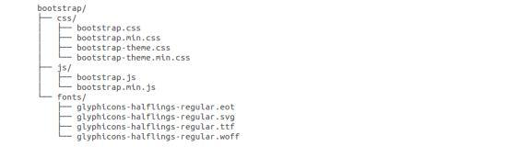

As you can see there are compiled CSS and JS (bootstrap.*), as well as compiled and minified CSS and JS (bootstrap.min.*). Fonts from Glyph icons are included, as is the optional Bootstrap theme.

**CSS**

Bootstrap comes with feature of global CSS settings, fundamental HTML elements styled and enhanced with extensible classes, and an advanced grid system. This is covered in detail in the section **Bootstrap with CSS**.

**Components**

Bootstrap contains over a dozen reusable components built to provide iconography, dropdowns, navigation, alerts, popovers, and much more.

**JavaScript Plugins**

Bootstrap contains over a dozen custom jQuery plugins. You can easily include them all, or one by one. This is covered in details in the section **Bootstrap Plugins**.

.

**How do you get Bootstrap Package?**

You can download the latest version of Bootstrap from http://getbootstrap.com/. When you click on this link, you will get to see a screen as below:

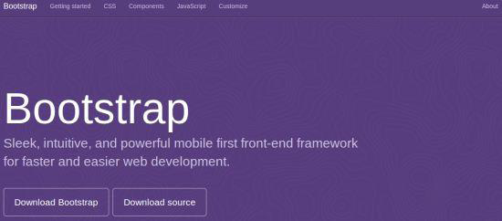

Here you can see two buttons:

**Download Bootstrap:**

Clicking this, you can download the precompiled and minified versions of Bootstrap CSS, JavaScript, and fonts. No documentation or original source code files are included.

**Download Source:**

Clicking this, you can get the latest Bootstrap LESS and JavaScript source code directly from GitHub.

**9.1INTRODUCTION OF DATABASE TOOLS**

**Introduction**

* MySQL is an open source Relational database management system that relies on SQL for processing the data in the database.
* MySQL falls under General Public License (GPL).
* MySQL provides APIs for the languages JAVA, .NET, PHP, Python etc.
* MySQL is most commonly widely used for web applications because of its speed and reliability.
* MySQL provides very high performance and it is multi-threaded and multi user relational database management system.
* MySQL supports indexing and binary objects.
* MySQL can run on almost all the platforms.

**Features of MySQL**

**Scalability and flexibility**

* MySQL can run on almost all the platforms like Windows, Linux and UNIX etc.
* The open source nature of MySQL allows complete customization for these wanting to add unique requirements the database server.

**High Performance**

* MySQL can meet all the today’s requirements to the database server. A billions queries, high speed transaction etc.

**High Availability**

* Rock-solid reliability and constant availability are main feature of MySQL.

**Robust Transaction Support**

* MySQL supports complete ACID transaction support, unlimited row-level locking, distribution transaction capability, and multi version transaction
* Server-enforced referential integrity, specialized transaction isolation levels, and instant deadlock detection and achieve data integrity.

**Backup and Recovery**

* MySQL supports complete logical and physical backups as well as full and point-in-time recovery.

**Comprehensive Application Development**

* MySQL supports stored procedures, triggers, functions, views, cursors, Sub-SELECTs, and more.
* 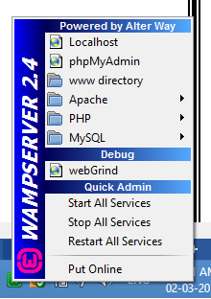MySQL supports connectors and drivers (ODBC, JDBC, etc.) for database connection.

**Introduction**



* PhpMyAdmin is a graphical user interface program that allows you to use the functions of MySQL database.
* With phpMyAdmin we can perform various tasks such as creating, modifying, deleting databases, tables, fields, rows, Import data in SQL format and Export data in SQL format, XML, executing SQL statements, managing user’s permissions, administering multiple servers.
* To open phpMyAdmin just right click, on wampserver and go to phpMyAdmin as below:

**Various Parts Of phpMyAdmin**

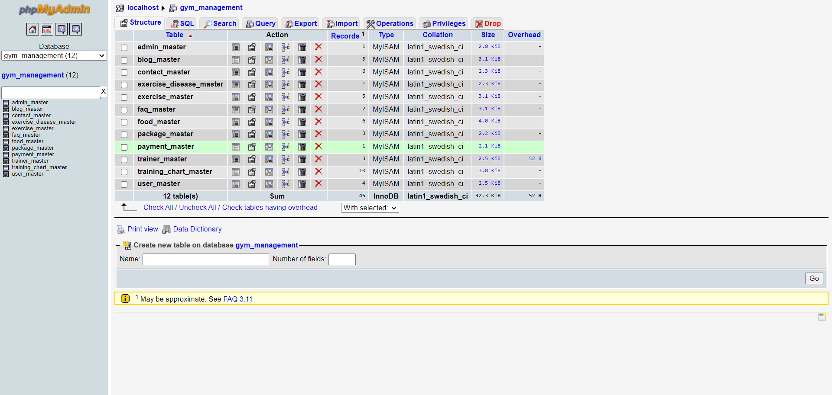

**10.WAMP**

**Introduction**



* The WAMP stands for Windows Apache MySQL and PHP. It is a Windows web development environment. It allows you to create web applications with Apache, PHP and MySQL database.

**11PROJECT DESCRIPTION**

**11.1MANUAL & EXISTING SYSTEM**

* The Manual System no one can able to get proper adivasi culture related information (scheme, job, office contact number, news, etc.) and not provide any document, form.
* They have to manually visit office to get any sort of adivasi scheme related, jobs related information.
* There were much more difficulties in getting any information and not be provided overall information in one place.

**11.2NEED FOR NEW SYSTEM**

* + It`s Online application that will going to provide all the information about the existing system as well as all the kind of Adivasi related information and information related to job, news, festivals and different kind of cultures.
  + It`s much more easier to get all the information and document online without wasting of time and available to everyone.
  + They will be able to get all the sort of information related to fair, festivals, schemes, tribes detail, job detail and other related news.

**12.FUNCTIONAL SPECIFICATION**

**12.1Module:-**

* **User Master**
* **Login**
* **Change password**
* **Forget password**
* **Manage profile**
* **About us**
* **Classes**
* **Gallery**
* **Blog**
* **FAQ**
* **Trainer Master**
* **Training chart Master**
* **Food Analog Master**
* **Exercise Master**
* **Package Master**
* **Contact Master**
* **Exercise disease Master**

**12.2Module specification**

**User Master:-**

* In this module Admin can Registration form to the website And manage Whole Website

**Login:-**

* In this module Admin can login to the website and manage whole website.

**Change password:-**

* In this module Admin can change their password.

**Forget password:-**

* In this module Admin can forgot password and reset new password.

**Manage profile:-**

* In this module Admin can manage their profile like update their name, mobile number, e-mail etc.

**About us:-**

* In this module Admin can manage about us. Like update, view.
* In this module visitor can view about us.

**Gallery**

**Photo gallery:-**

* In this module admin can manage photo gallery. Like add, update, delete and view photos.
* In this module visitor can view photo gallery.

**Contact Master:-**

* In this module admin can manage contact us. Edit, view.
* In this module visitor can view contact us.

**package Master:-**

* In this modules Admin can Add package

**Trainer Master:-**

* In this modules admin can add trainer detail

**Training chart Master:-**

* In this modules admin can Add the training chart Detail

**Exercise master**

* In this modules Admin can Add Exe master Detail

**Food Analog Master**

* In this modules Admin can Add Diet master Detail

**Exercise disease Master**

* In this modules Admin can Add Exe disease

**13.USERS OF THE SYSTEM**

In our system there are two users who can work on the system they are :-

1. Admin
2. Users

**13.1User specification**

**Admin:-**

* + Admin can manage Login
  + Admin can manage user detail
  + Admin can manage Trainer detail
  + Admin can manage Exercise for disease
  + Admin can manage food Analog
  + Admin can manage Training Chart
  + Admin can manage package
  + Admin can manage Blog
  + Admin can manage FAQ
  + Admin can manage contact us
  + Admin can log out

**User:-**

* + User can Registration
  + User can Login
  + User can manage user detail
  + User can view Trainer detail
  + User can view Exercise for disease
  + User can view food Analog
  + User can view Training Chart
  + User can view/Buy package
  + User can view Blog
  + User can view FAQ
  + User can view contact us
  + User can log out

**14.FEASIBILITY STUDY**

A feasibility study is a short, focused study, which aims to answer a number of questions:

* Does the system contribute to the overall objectives of the Organization?
* Can the system be implemented using current technology and within given cost and schedule constraints?
* Can the system be integrated with systems which are already in place?

**There are four types of Feasibility Study**

1. **Economic Feasibility**

Economic Feasibility addresses to the following issues:

* Is the organization having the suitable budget to develop the proposed system?
* How much profit can be earned from the system by an organization?
* Would it be cost-effective to develop the system or it is worthwhile to remain with current system?

We would like to answer for the above question, as given below:

* As development tools and software are available, there isn’t any burden of buying them.
* The organization doesn’t having the same system, so it is certainly required for them.
* The profit will be remarkable according to our team has seen as far as market is concerned.
* So, here we do not need to invest extra funds to develop the system. Thus, it is economically feasible to the Organization.

1. **Technical Feasibility**

Technical feasibility tries to answer the following questions to make the software feasible to develop.

* The software or tools necessary for building or running the application are easily available or not?
* The compatibility amongst software exists or not?
* Are developers aware of these technologies?
* What about the alternative of these chosen technologies?

Factors Considered:

* Here we have to consider those tools that will be required for developing the project.
* The tools that are available and tools that will be required have to take in account./
* We work on **Notepad++, Bootstrap**. The company's former versions are developed in **MySQL**. So company already has the licensed version of Microsoft Product.
* As far as basic knowledge is concerned we had done C, C++, and Visual Basic. We have well experience knowledge of VB.NET and its Technologies. Various technical books, e-books etc. are available.
* Internet facility is always available for technical as well as advanced software help.
* Considering all above points and aspects it is observed that would be incurred in developing this project from a technical perspective would not be too high. Thus it is feasible to company.

1. **Operational Feasibility**

Operational feasibility measures how well the solution will work in the organization and how will end-user & management feels about system. Proposed system is helpful for the tourists, citizen and visitors. It will allow them to query them to get the appropriate and adequate information.

On studying the operational feasibility of the project, the following conclusions could be derived:

* Developed system will provide the adequate throughput and all necessary information to end-users.
* It will provide advantageous and reliable services.
* If it can be within suitable environment, system will do operations under environment of limited resources.

Thus, it is operationally feasible to develop the proposed system.

1. **Scheduled Feasibility**

The purpose of accessing schedule feasibility is to gain an understanding of likelihood that all potential time frames and completion date schedules can be met.

With deadline of 80 days and with PHP, MySQL, AJAX, Dreamweaver, Notepad++ the system seems to be quite feasible in terms of schedule.

**15.PROJECT TIME SCHEDULING**

|  |  |  |  |
| --- | --- | --- | --- |
| SR.NO | TASK | FROM  01-12-2022 To 28-02-2019 | TOTAL DAYS |
| 1 | Requirement Gathering | 01-12-2022 To 07/12/2018 | 07 |
| 2 | System Analysis Designing | 08/12/2018 To 23/12/2018 | 16 |
| 3 | UI Designing | 24/12/2018 To 26/01/2019 | 34 |
| 4 | Coding | 27/01/2019 To 20/02/2019 | 25 |
| 5 | Testing | 21/02/2019 To 25/02/2019 | 5 |
| 6 | Implementation | 26-02-2019 to 28-02-2019 | 3 |

**15.1Time line Chart**

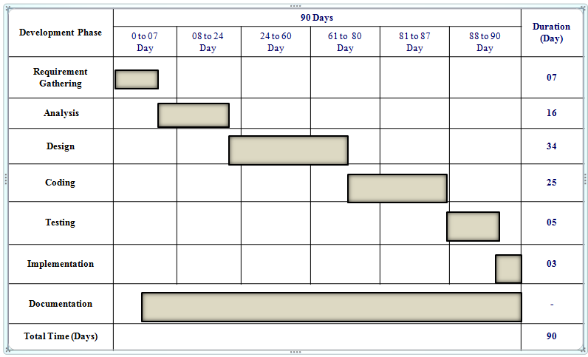

**16.FLOW CHART**

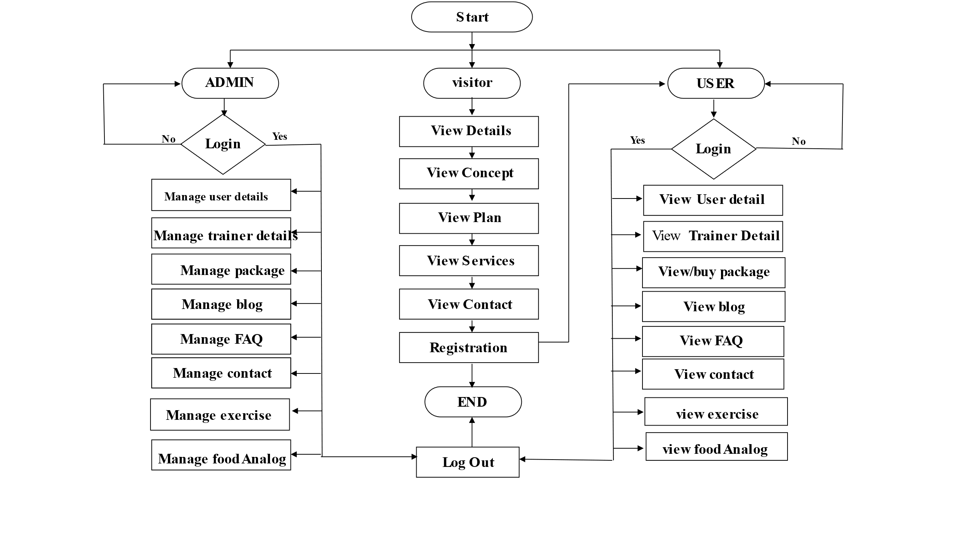

**17. DFD(DATA FLOW DIAGRAM)**

**CONTEXT LEVEL DFD**

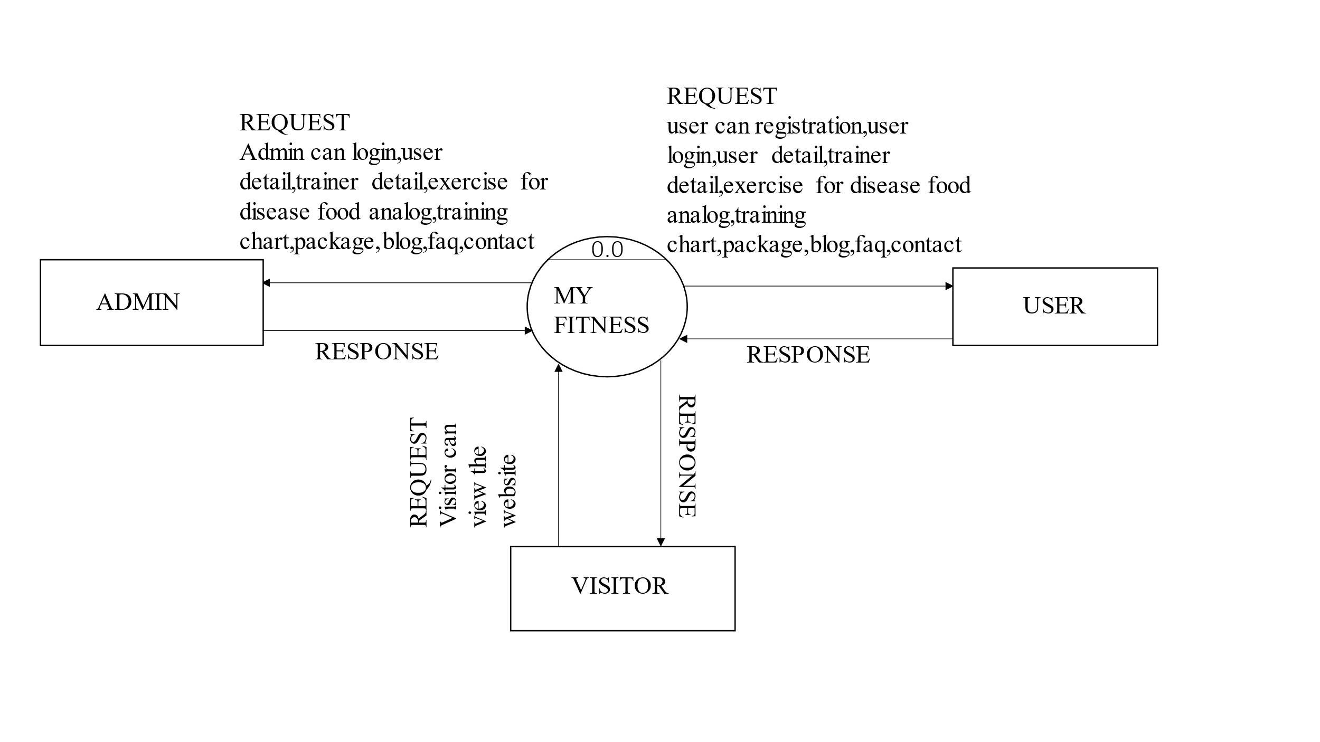

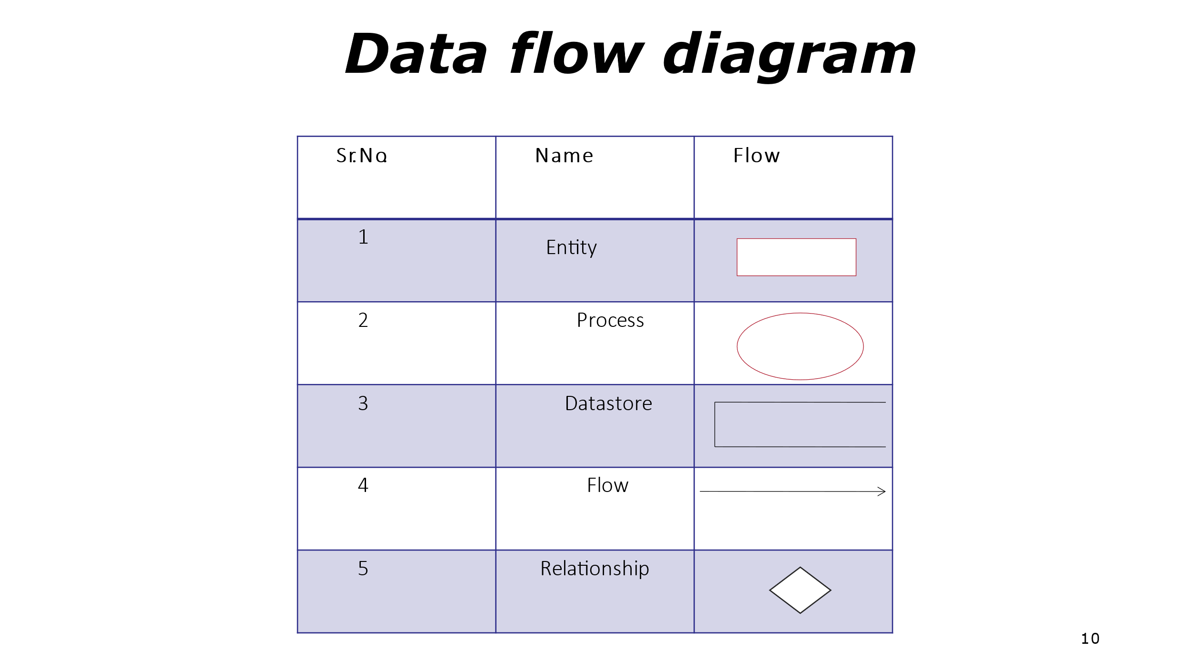

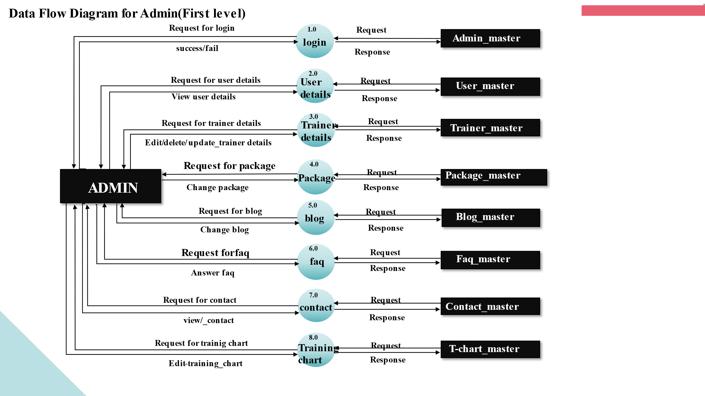

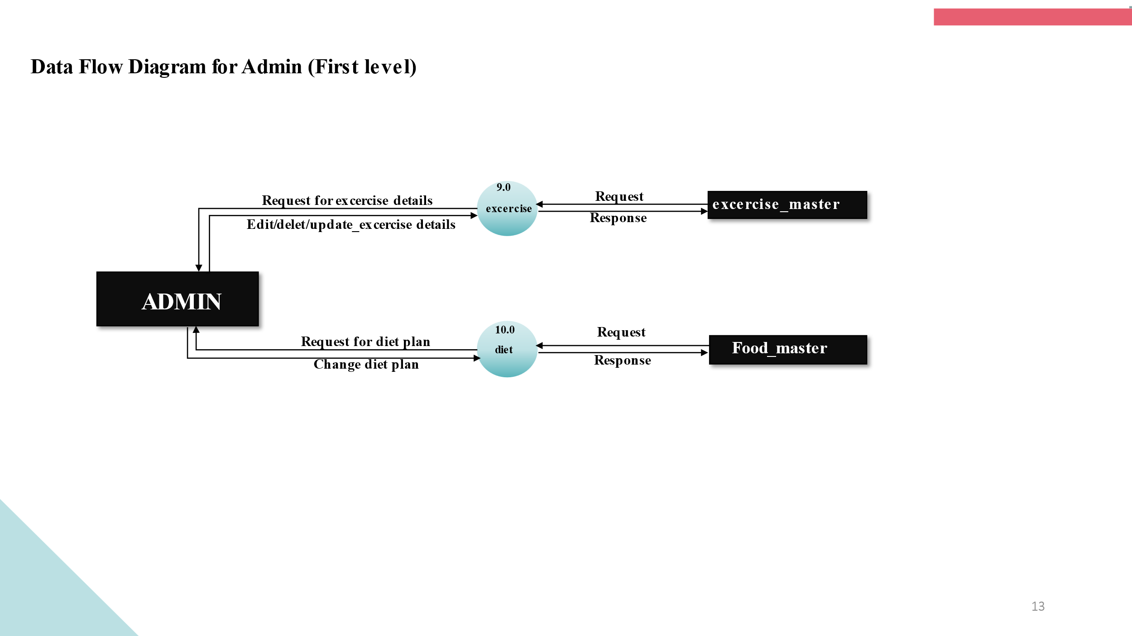

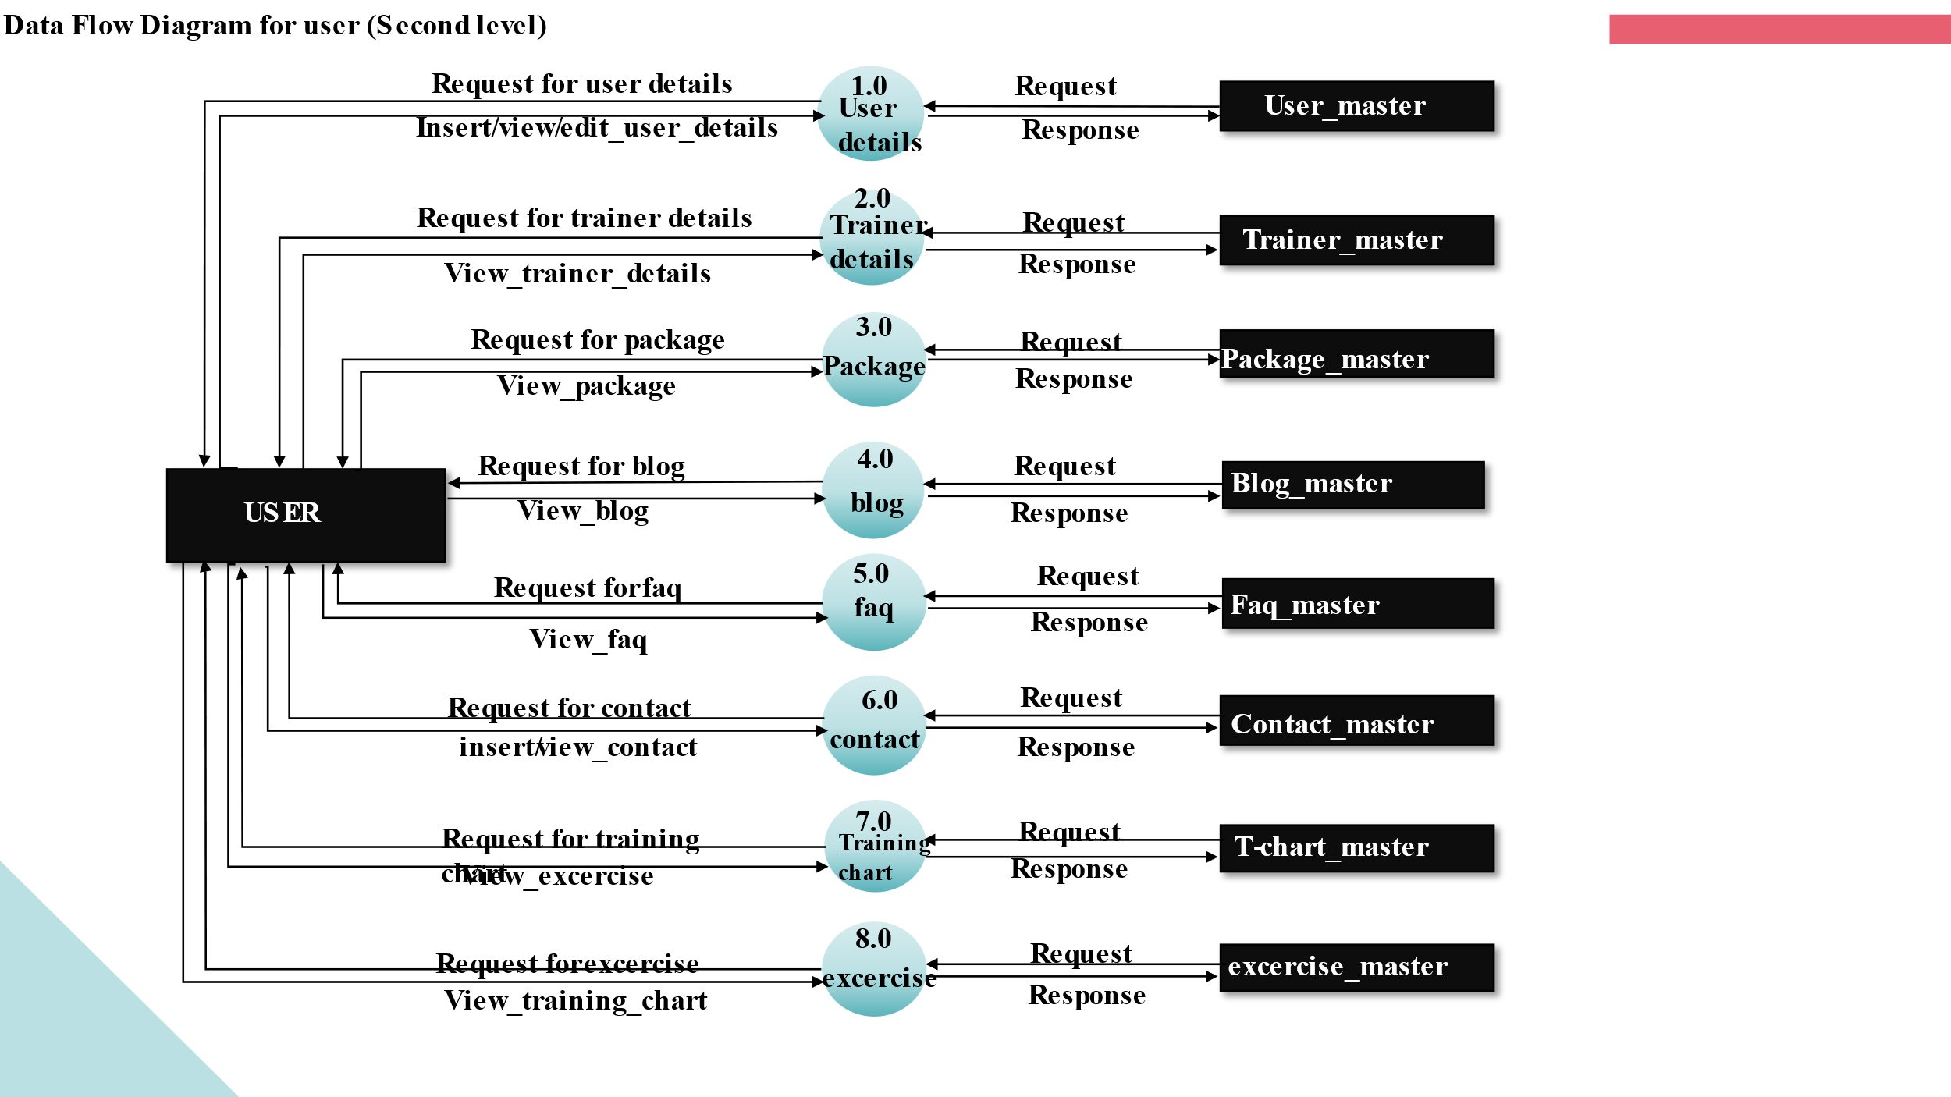

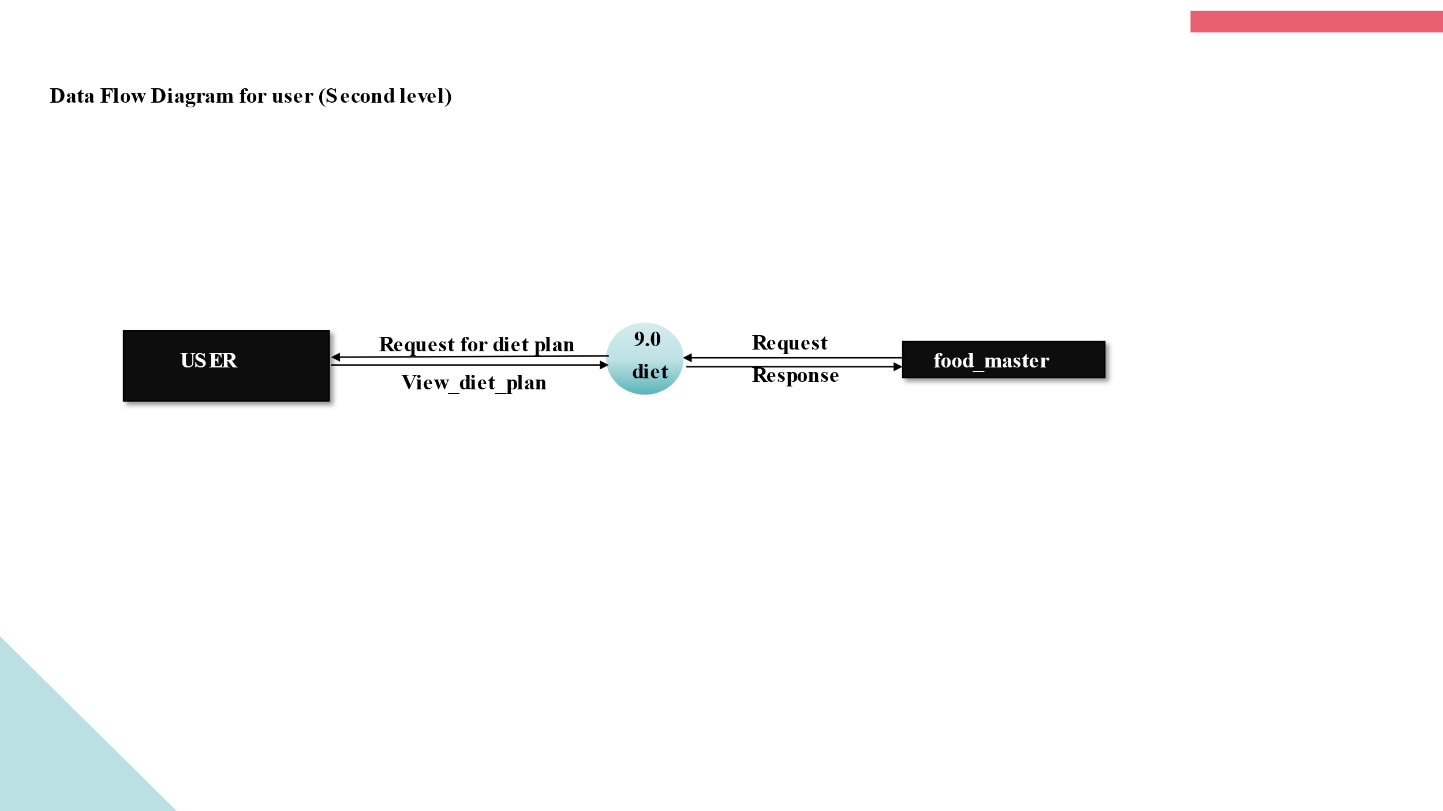

**18.DATA DICTIONARY**

**TABLE SUMMERY**

|  |  |
| --- | --- |
| Sr.no | Fields |
| 1 | **Admin Login** |
| 2 | **User Master** |
| 3 | **Food Analog Master** |
| 4 | **Exercise Master** |
| 5 | **Contact Master** |
| 6 | **Exercise Disease Master** |
| 7 | **Package Master** |
| 8 | **Payment Master** |
| 9 | **Blog Master** |
| 10 | **Trainer Master** |
| 11 | **FAQ Master** |
| 12 | **Training chart Master** |

**TABLES**

Table Name:- **Admin Login**

Description:- This table is used to store Admin detail.

|  |  |  |  |  |  |
| --- | --- | --- | --- | --- | --- |
| **Sr No.** | **Fields** | **Fields Type** | **Allow Null** | **Primary Key** | **Description** |
| 1 | id | Int(10) | No | Yes | Serial Number |
| 2 | Username | Varchar(25) | No | No | username |
| 3 | password | Varchar(15) | No | No | Password |
| 4 | createdate | DateTime | No | No | Createdate |

Table Name:- **User Master**

Description:- its use to store for **User Master**

|  |  |  |  |  |  |
| --- | --- | --- | --- | --- | --- |
| **Sr No.** | **Fields** | **Fields Type** | **Allow Null** | **Primary Key** | **Description** |
| 1 | User_ID | Int(25) | No | Yes | User_ID |
| 2 | Full Name | Varchar(20) | No | No | Full Name |
| 3 | Username | Varchar(20) | No | No | Username |
| 4 | Email | Varchar(25) | No | No | Email |
| 5 | Password | Varchar(15) | No | No | Password |
| 6 | Contact | Varchar(10) | No | No | Contact |
| 7 | Height | Varchar(10) | No | No | Height |
| 8 | Weight | Varchar(100) | No | No | Weight |
| 9 | Blood group | Varchar(4) | No | No | Blood Group |
| 10 | Gender | Varchar(2) | No | No | Gender |
| 11 | Address | Varchar(100) | No | No | Address |
| 12 | City | Varchar(25) | No | No | City |

Table Name:- **Food Analog _master**

**Description:- its use to store for Food Analog_master**

|  |  |  |  |  |  |
| --- | --- | --- | --- | --- | --- |
| **Sr No.** | **Fields** | **Fields Type** | **Allow Null** | **Primary key** | **Description** |
| **1** | **Id** | **int(10)** | **no** | **yes** | **Diet ID** |
| **2** | **User_id** | **int(10)** | **no** | **no** | **User ID** |
| **3** | **b_monday** | **Text** | **no** | **no** | **Breakfast Monday** |
| **4** | **l_monday** | **Text** | **no** | **no** | **Lunch Monday** |
| **5** | **d_monday** | **Text** | **no** | **no** | **Dinner Monday** |
| **6** | **b_tuesday** | **Text** | **no** | **no** | **Breakfast Tuesday** |
| **7** | **l_tuesday** | **Text** | **no** | **no** | **Lunch Tuesday** |
| **8** | **d_tuesday** | **Text** | **no** | **no** | **Dinner Tuesday** |
| **9** | **b_wednesday** | **Text** | **no** | **no** | **Breakfast Wednesday** |
| **10** | **l_wednesday** | **Text** | **no** | **no** | **Lunch Wednesday** |
| **11** | **d_wednesday** | **Text** | **no** | **No** | **Dinner Wednesday** |
| **12** | **b_thursday** | **Text** | **no** | **No** | **Breakfast Thursday** |
| **13** | **l_thursday** | **Text** | **no** | **No** | **Lunch Thursday** |
| **14** | **d_thursday** | **Text** | **No** | **No** | **Dinner Monday** |
| **15** | **b_friday** | **Text** | **No** | **No** | **Breakfast Thursday** |
| **16** | **l_friday** | **Text** | **No** | **No** | **Lunch Thursday** |
| **17** | **d_friday** | **Text** | **No** | **No** | **Dinner Thursday** |
| **18** | **b_saturday** | **Text** | **No** | **No** | **Breakfast Saturday** |
| **19** | **l_saturday** | **Text** | **No** | **No** | **Lunch Saturday** |
| **20** | **d_saturday** | **Text** | **No** | **No** | **Dinner Monday** |
| **21** | **b_sunday** | **Text** | **No** | **No** | **Breakfast Sunday** |
| **22** | **l_sunday** | **Text** | **No** | **No** | **Lunch Sunday** |
| **23** | **d_sunday** | **Text** | **No** | **no** | **Dinner Sunday** |

Table Name:- **exercise_master**

**Description:- its use to store for exercise_master**

|  |  |  |  |  |  |
| --- | --- | --- | --- | --- | --- |
| **Sr No.** | **Fields** | **Fields Type** | **Allow Null** | **Primary key** | **Description** |
| 1 | Id | int(10) | no | yes | Diet ID |
| 2 | User_id | int(10) | no | no | User ID |
| 3 | S1_monday | Text | no | no | S1 Monday |
| 4 | S2_monday | Text | no | no | S2 Monday |
| 5 | S3_monday | Text | no | no | S3Monday |
| 6 | S1_tuesday | Text | no | no | S1 Tuesday |
| 7 | S2_tuesday | Text | no | no | S2 Tuesday |
| 8 | S3_tuesday | Text | no | no | S3 Tuesday |
| 9 | S1_wednesday | Text | no | no | S1 Wednesday |
| 10 | S2_wednesday | Text | no | no | S2 Wednesday |
| 11 | S3_wednesday | Text | no | no | S3 Wednesday |
| 12 | S1_thursday | Text | no | no | S1 Thursday |
| 13 | S2_thursday | Text | no | No | S2 Thursday |
| 14 | S3_thursday | Text | N | No | S3 Monday |
| 15 | S1_friday | Text | No | No | S1 Thursday |
| 16 | S2_friday | Text | No | No | S2 Thursday |
| 17 | S3_friday | Text | No | No | S3 Thursday |
| 18 | S1_saturday | Text | No | No | S1 Saturday |
| 19 | S2_saturday | Text | No | No | S2 Saturday |
| 20 | S3_saturday | Text | No | No | S3 Monday |
| 21 | S1_sunday | Text | No | No | S1 Sunday |
| 22 | S2_sunday | Text | No | No | S2 Sunday |
| 23 | S3_sunday | Text | No | no | S3 Sunday |

**TABLE NAME:- contact Master**

Description:- its use to store for contact Master

|  |  |  |  |  |  |
| --- | --- | --- | --- | --- | --- |
| **Sr No.** | **Fields** | **Fields Type** | **Allow Null** | **Primary Key** | **Description** |
| 1 | Sr_no | Int(10) | No | Yes | Serial Number |
| 2 | name | Varchar(20) | No | No | Name |
| 3 | email | Varchar(20) | No | No | Email |
| 4 | message | Varchar(100) | No | No | Message |

**TABLE NAME:- exercise_disease Master**

Description:- its use to store for **exercise_disease Master**

|  |  |  |  |  |  |
| --- | --- | --- | --- | --- | --- |
| **Sr No.** | **Fields** | **Fields Type** | **Allow Null** | **Primary Key** | **Description** |
| 1 | Exercise_id | int(10) | No | Yes | Serial Number |
| 2 | Exercise_title | varchar(50) | No | No | Exercise_title |
| 3 | Exercise_name | Varchar(50) | No | No | Exercise_name |
| 4 | Exercise_description | varchar(100) | No | No | Exercise_description |
| 5 | exercise_image | varchar | No | No | exercise_image |
| 6 | createdate | DateTime | No | No | createdate |

**TABLE NAME:- Package Master**

Description:- its use to store for Package Master

|  |  |  |  |  |  |
| --- | --- | --- | --- | --- | --- |
| **Sr No.** | **Fields** | **Fields Type** | **Allow Null** | **Primary Key** | **Description** |
| 1 | Package _id | int(10) | no | yes | Serial Number |
| 2 | Package _title | varchar(100) | no | no | Package _title |
| 3 | Package _description | Varchar(100) | no | no | Package _description |
| 4 | Package _type | varchar(200) | no | no | Package _type |
| 5 | Package _price | varchar(5) | No | No | Package _price |
| 6 | Package _Nutrition Advicer | varchar(100) | no | no | Package _Nutrition Advicer |
| 7 | createdate | DateTime | no | no | createdate |

**TABLE NAME:- Payment Master**

Description:- its use to store for Payment Master

|  |  |  |  |  |  |
| --- | --- | --- | --- | --- | --- |
| **Sr No.** | **Fields** | **Fields Type** | **Allow Null** | **Primary Key** | **Description** |
| **1** | **Payment_id** | **Int(10)** | **No** | **Yes** | **Serial Number** |
| **2** | **Payment_email** | **Varchar(50)** | **No** | **No** | **Payment_email** |
| **3** | **Payment_Proof** | **Varchar(100)** | **No** | **No** | **Payment_Proof** |
| **4** | **Payment_Message** | **Varchar(100)** | **No** | **No** | **Payment_Message** |
| **5** | **createdate** | **DateTime** | **No** | **No** | **Createdate** |

**TABLE NAME:- blog Master**

Description:- its use to store for blog **Master**

|  |  |  |  |  |  |
| --- | --- | --- | --- | --- | --- |
| **Sr No.** | **Fields** | **Fields Type** | **Allow Null** | **Primary Key** | **Description** |
| 1 | Blog_id | Int(10) | No | Yes | Serial Number |
| 2 | Blog_title | Varchar(50) | No | No | Blog_title |
| 3 | Blog_description | Varchar(100) | No | No | Blog_description |
| 4 | Blog_image | Varchar | No | No | Blog_image |
| 5 | createdate | DateTime | No | No | Createdate |

**TABLE NAME:- trainer Master**

Description:- its use to store for trainer **Master**

|  |  |  |  |  |  |
| --- | --- | --- | --- | --- | --- |
| **Sr No.** | **Fields** | **Fields Type** | **Allow Null** | **Primary Key** | **Description** |
| 1 | trainer_id | Int(10) | No | Yes | Serial Number |
| 2 | trainer_title | Varchar(50) | No | No | trainer_title |
| 3 | trainer_description | Varchar(100) | No | No | trainer_description |
| 4 | trainer_image | Varchar | No | No | trainer_image |
| 5 | createdate | DateTime | No | No | Createdate |

**TABLE NAME:- FAQ Master**

Description:- its use to store for FAQ **Master**

|  |  |  |  |  |  |
| --- | --- | --- | --- | --- | --- |
| **Sr No.** | **Fields** | **Fields Type** | **Allow Null** | **Primary Key** | **Description** |
| 1 | FAQ_id | Int(10) | No | Yes | Serial Number |
| 2 | FAQ_QUESTION | Varchar(250) | No | No | FAQ_QUESTION |
| 3 | FAQ_ANSWER | Varchar(250) | No | No | FAQ_ANSWER |
| 4 | createdate | DateTime | No | No | createdate |

**TABLE NAME:- training_chart Master**

Description:- its use to store for **training_chart Master**

|  |  |  |  |  |  |
| --- | --- | --- | --- | --- | --- |
| **Sr No.** | **Fields** | **Fields Type** | **Allow Null** | **Primary key** | **Description** |
| 1 | Id | int(10) | no | yes | Diet ID |
| 2 | User_id | int(10) | no | no | User ID |
| 3 | S1_monday | Text | no | no | S1 Monday |
| 4 | S1_tuesday | Text | No | No | S1tuesday |
| 5 | S1_Wednesday | Text | No | No | S1wednesday |
| 6 | S1_thrusday | Text | no | No | S1thrusday |
| 7 | S1_Friday | Text | No | No | S1friday |
| 8 | S1_Saturday | Text | No | No | S1saturday |
| 9 | S1_Sunday | Text | No | no | s1sunday |
| 10 | Createdate | DateTime | No | No | createdate |

**19.E-R DIAGRAM**

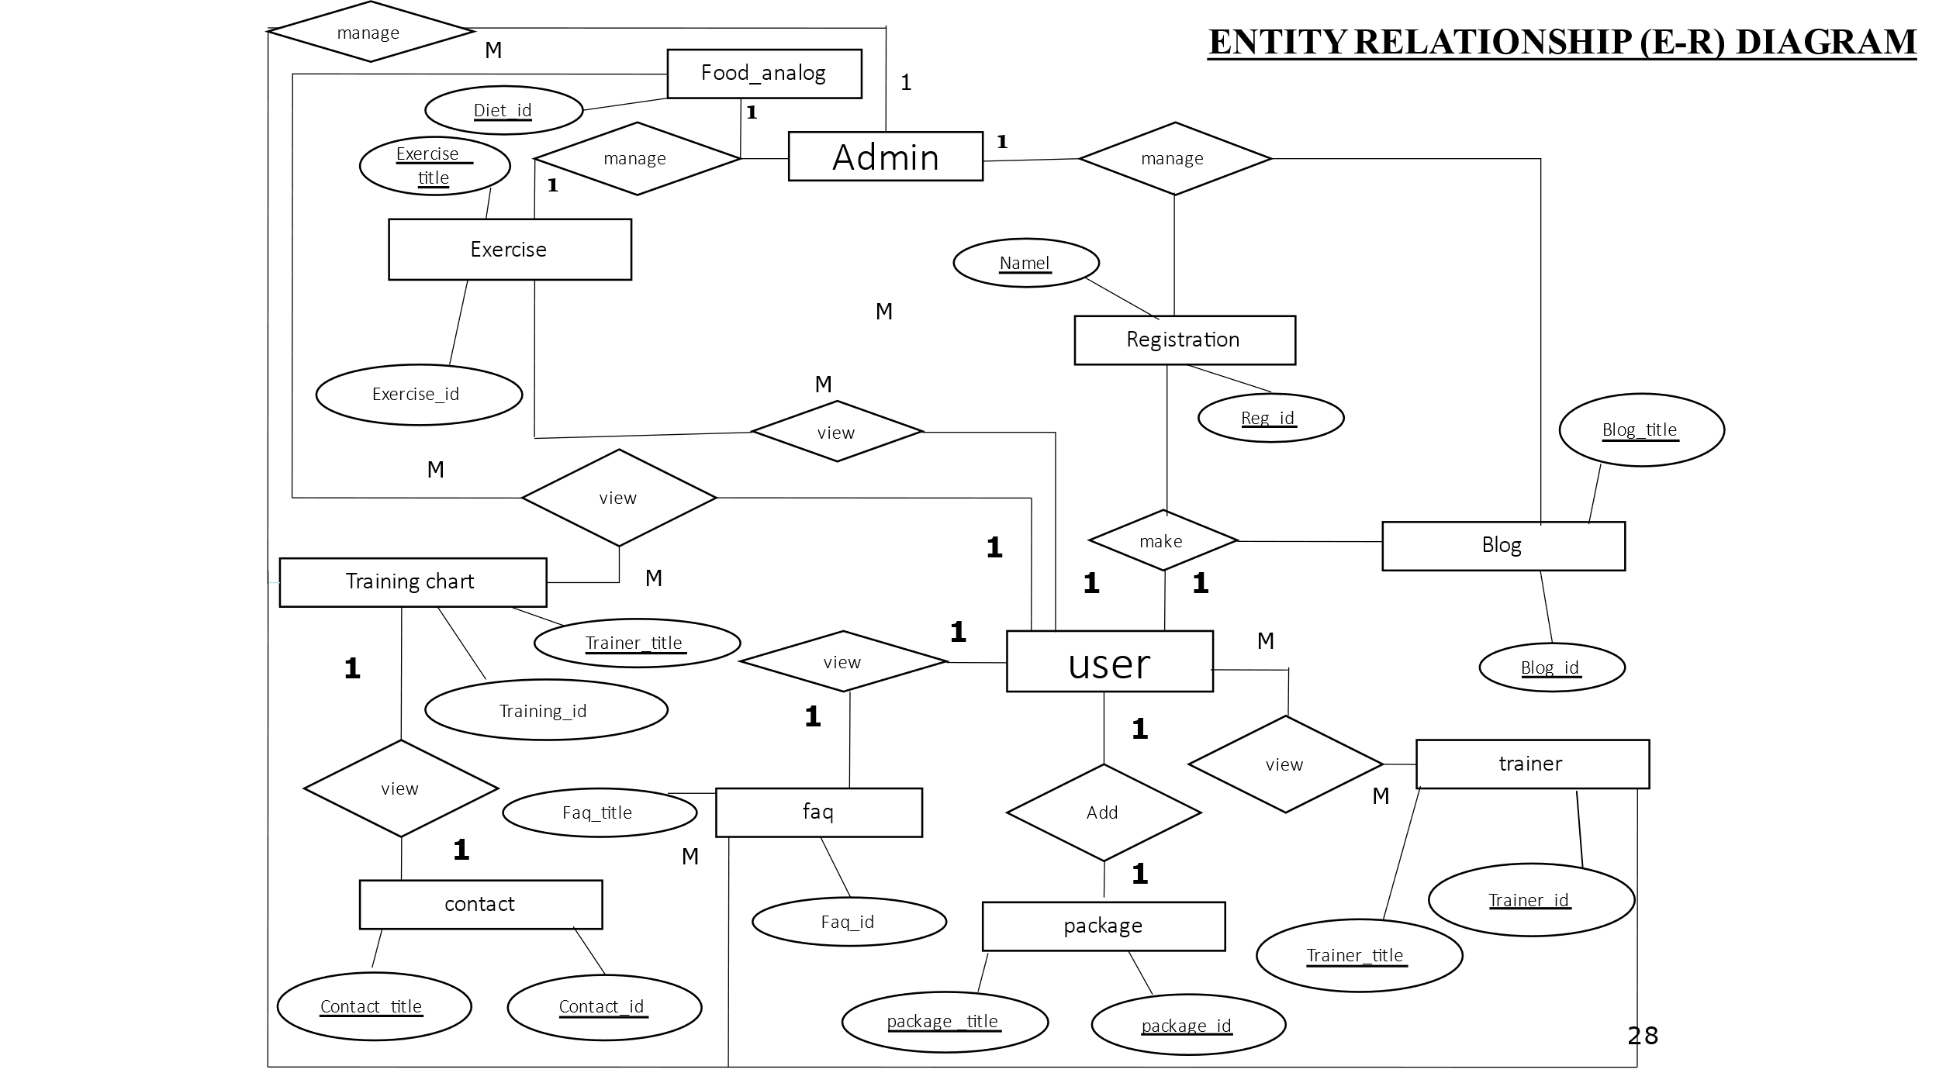

**20.USER INTERFACE DESIGN**

**ADMIN SIDE**

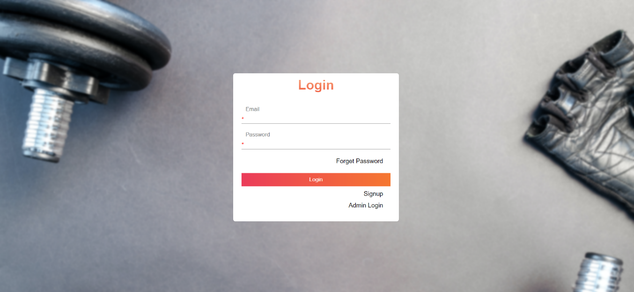

**LOGIN**

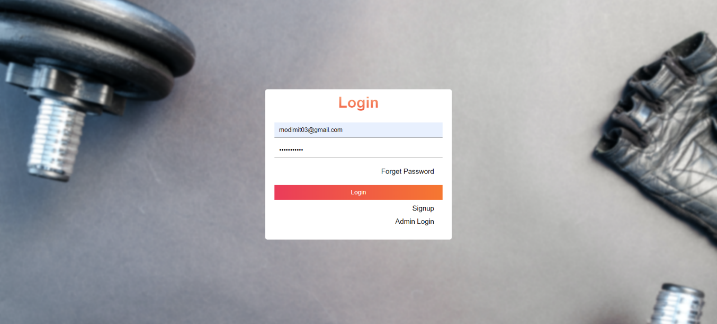

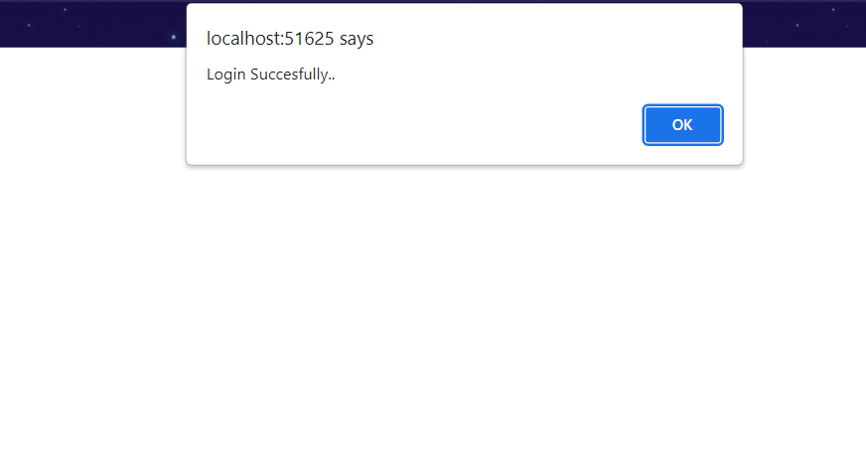

**SUCCESSFULLY LOGIN**

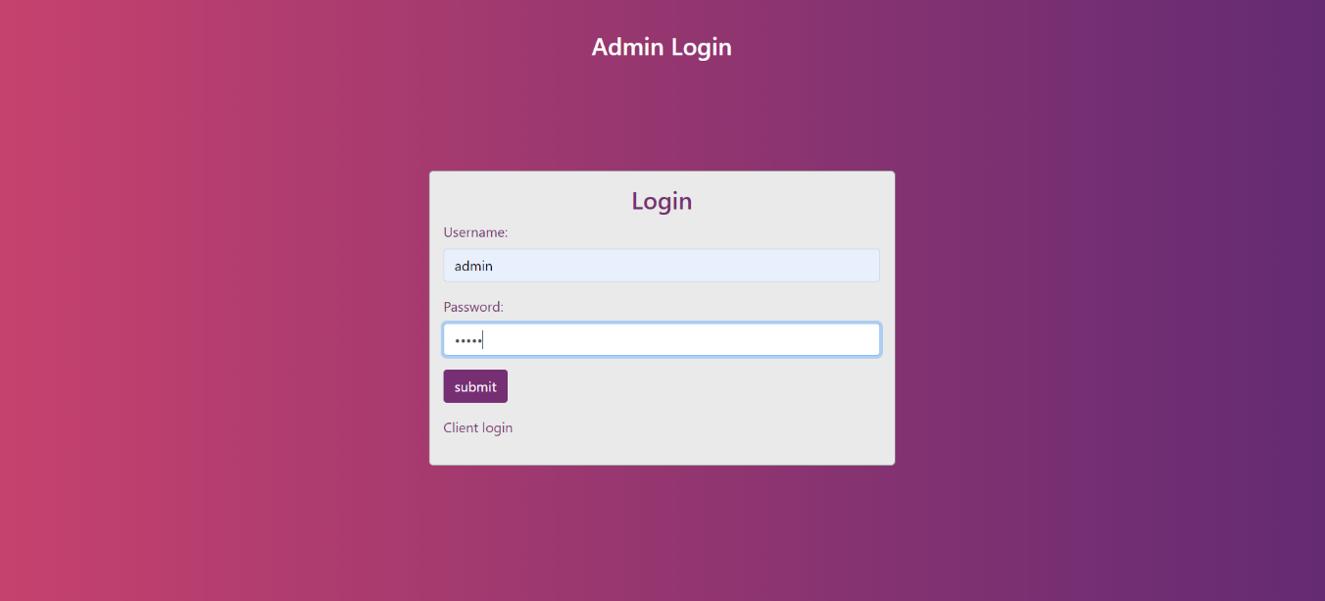

**ADMIN LOGIN**

**SUCCESSFULLY LOGIN**



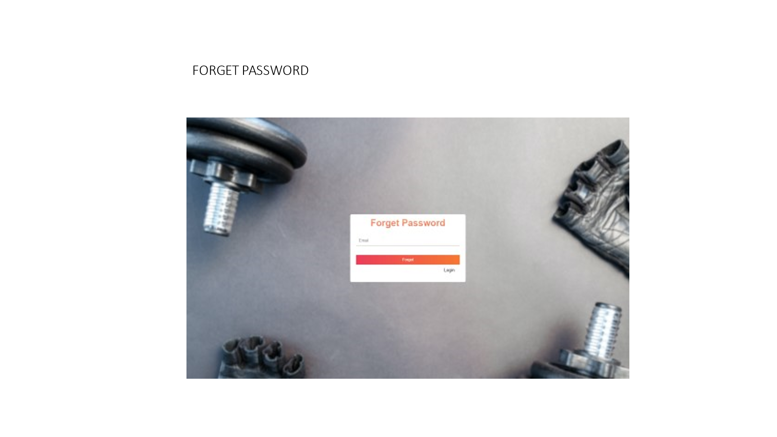

**FORGET PASSWORD**

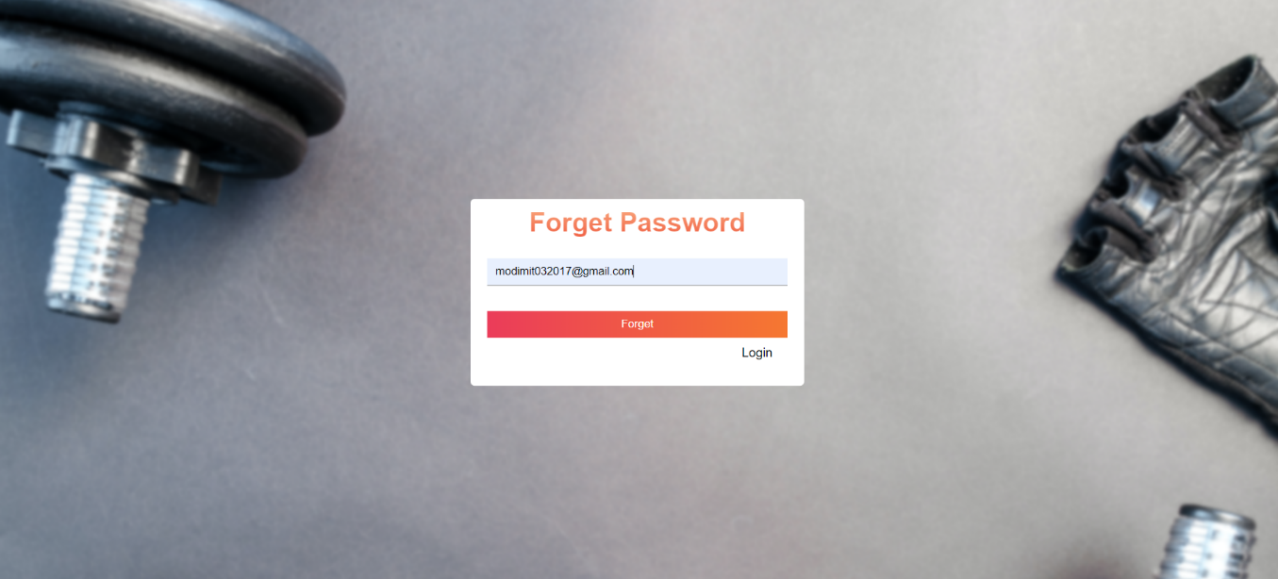

**OTP SEND**

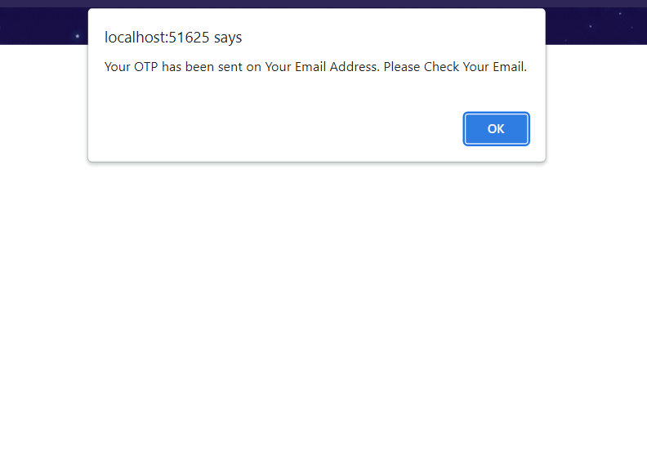

**OTP**



**CHANGE PASSWORD**

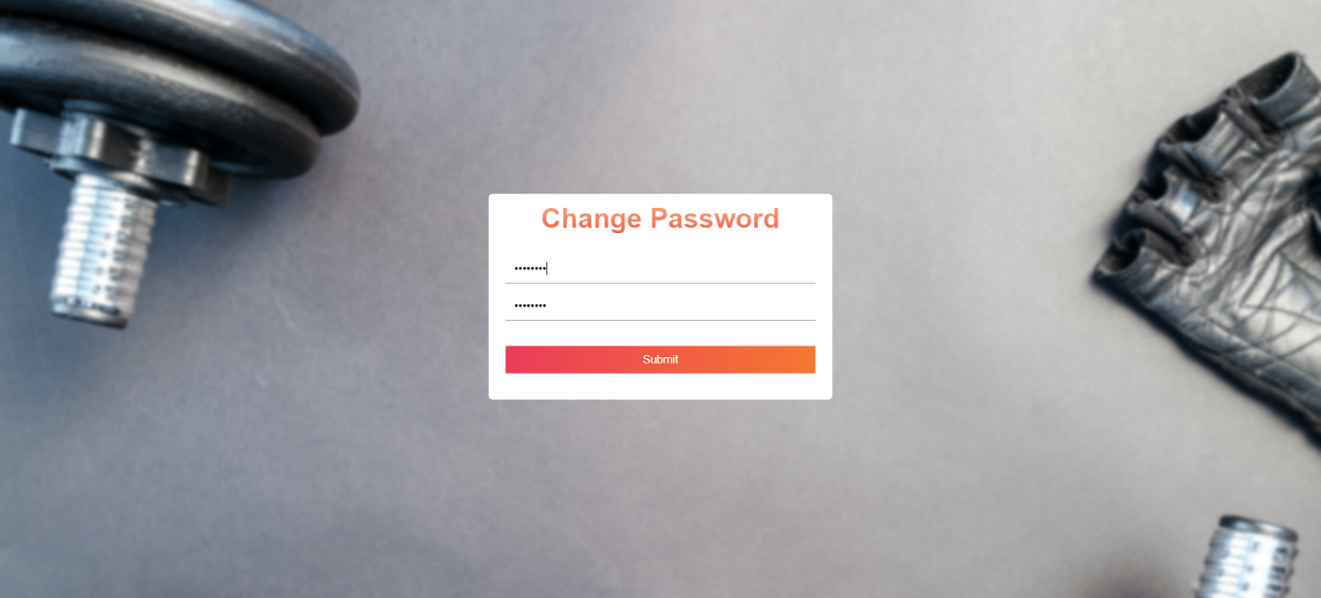

**CHANGE PASSWORD SUCCESSFULLY**

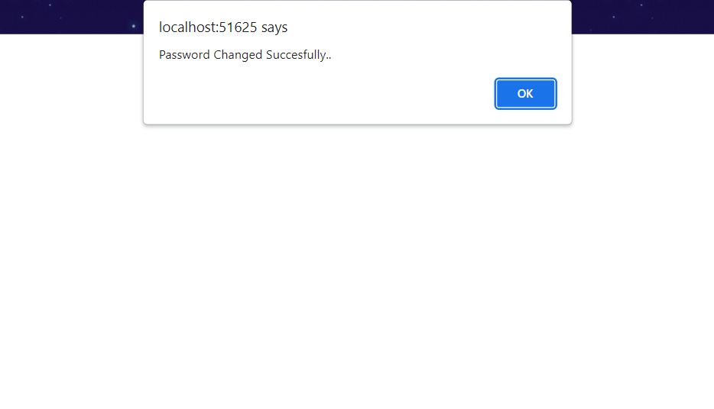

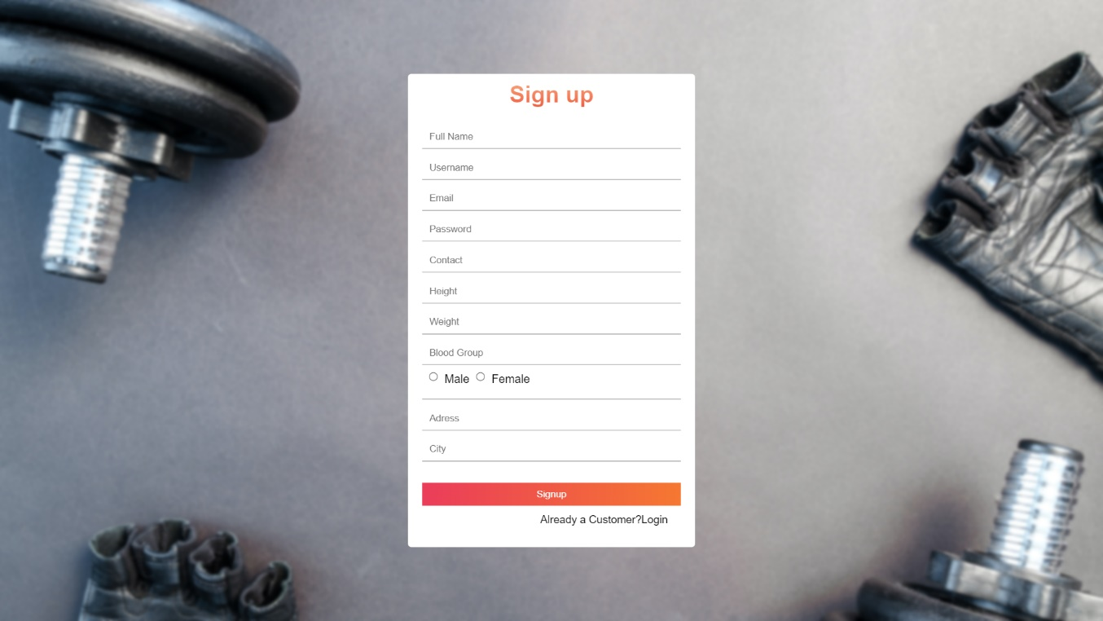

**SIGN UP**

**LOGIN**

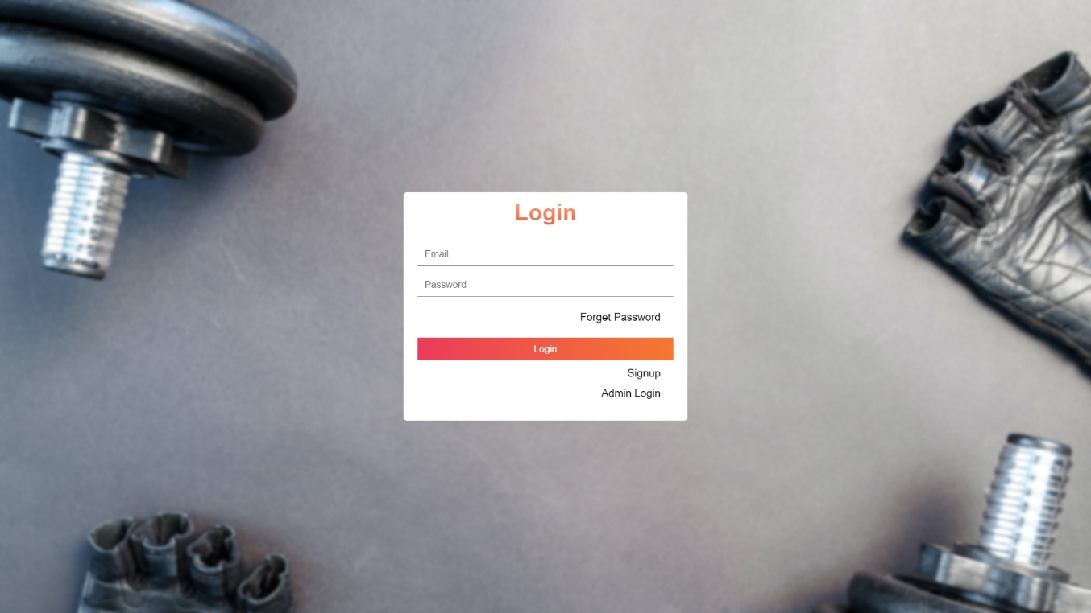

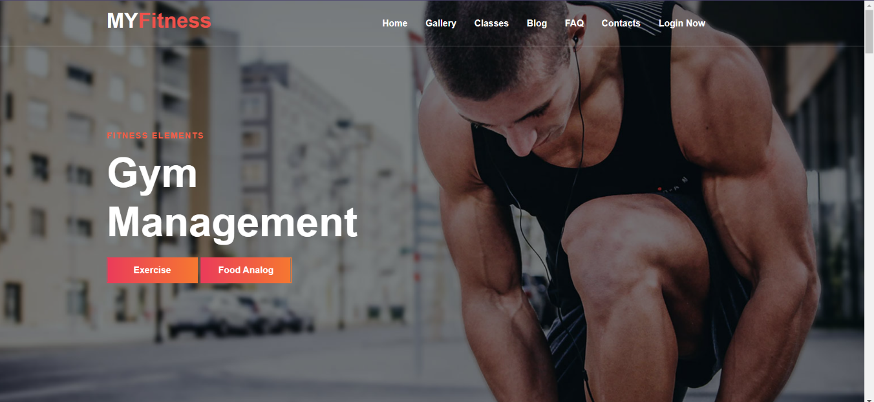**HOME**

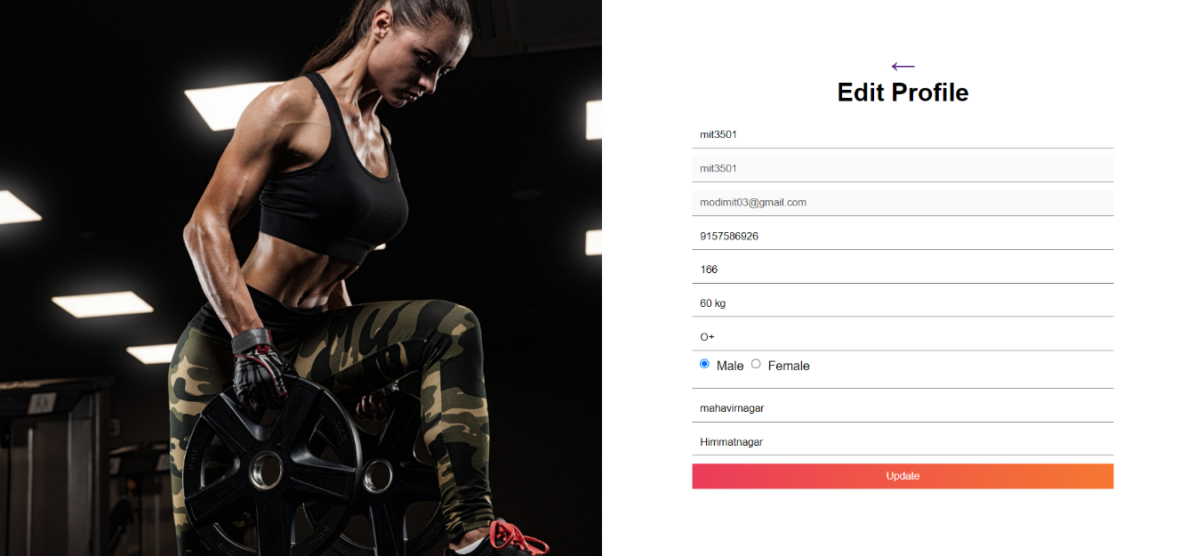

**EDIT PROFILE**

**ABOUT US**

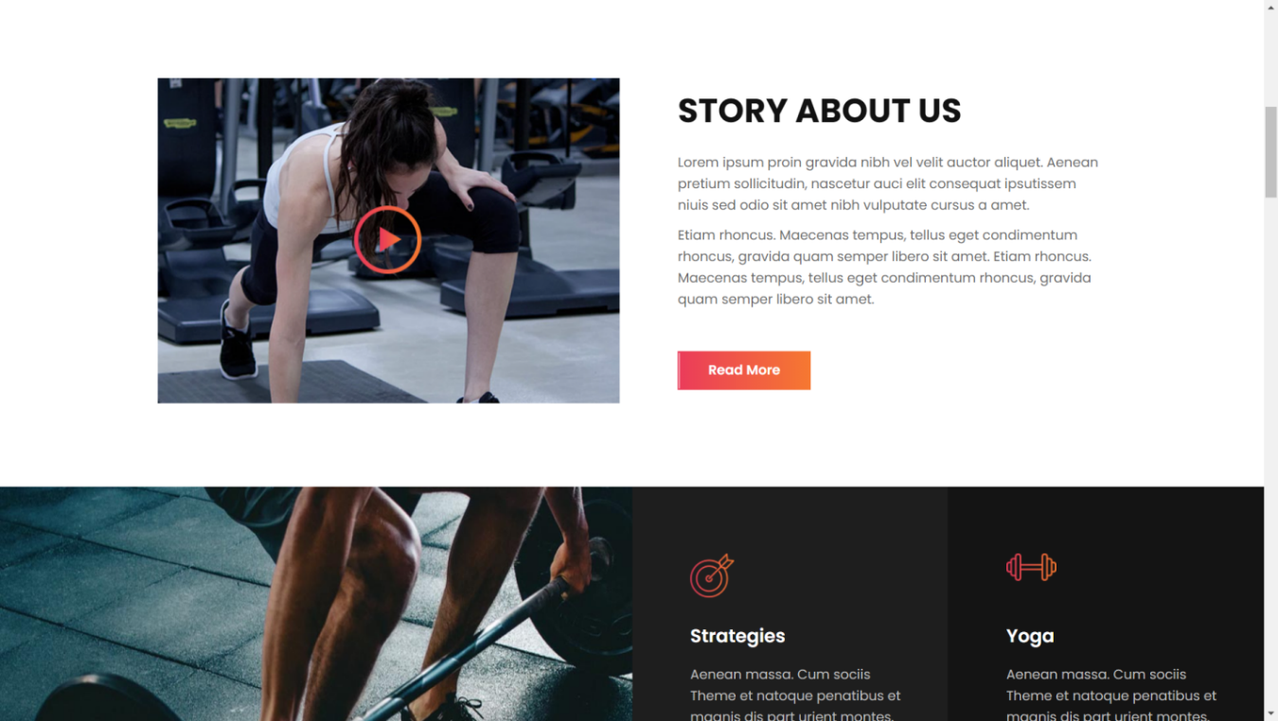

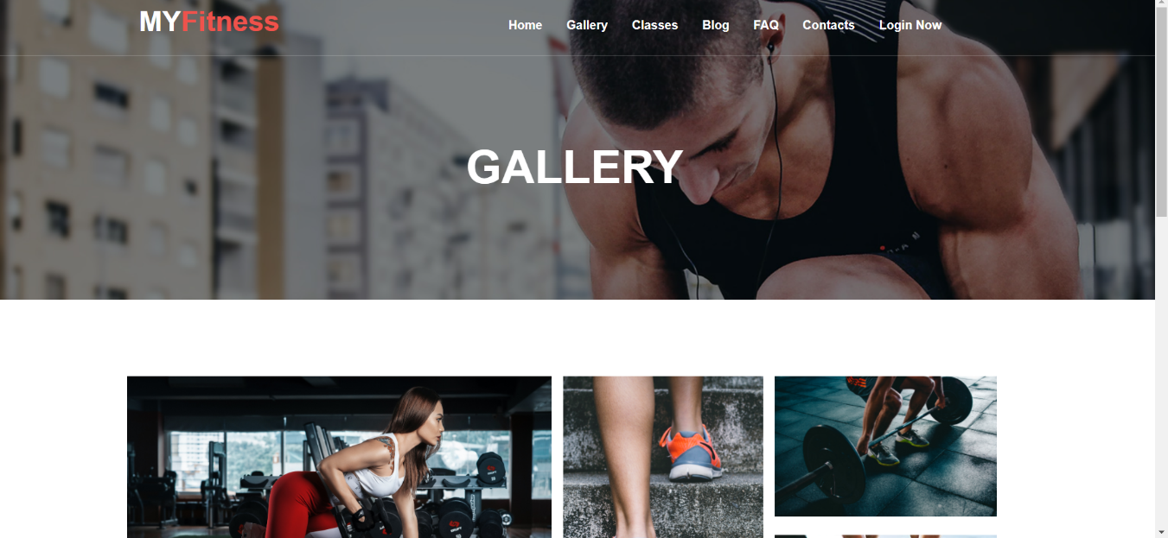**GALLERY**

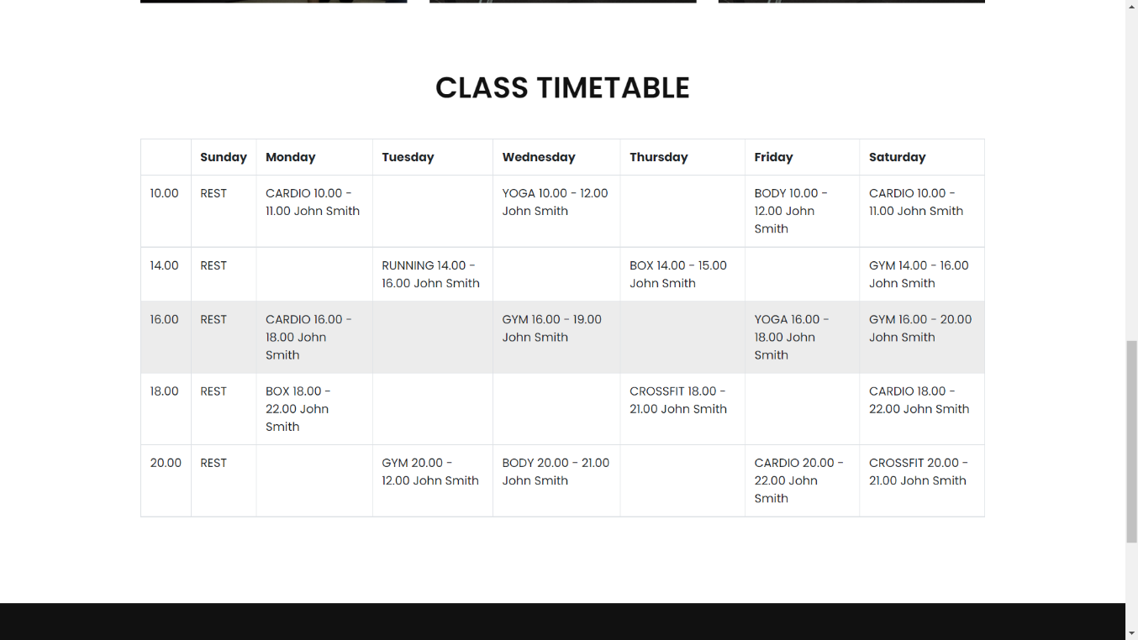

**CLASSES**

**EXERCISES**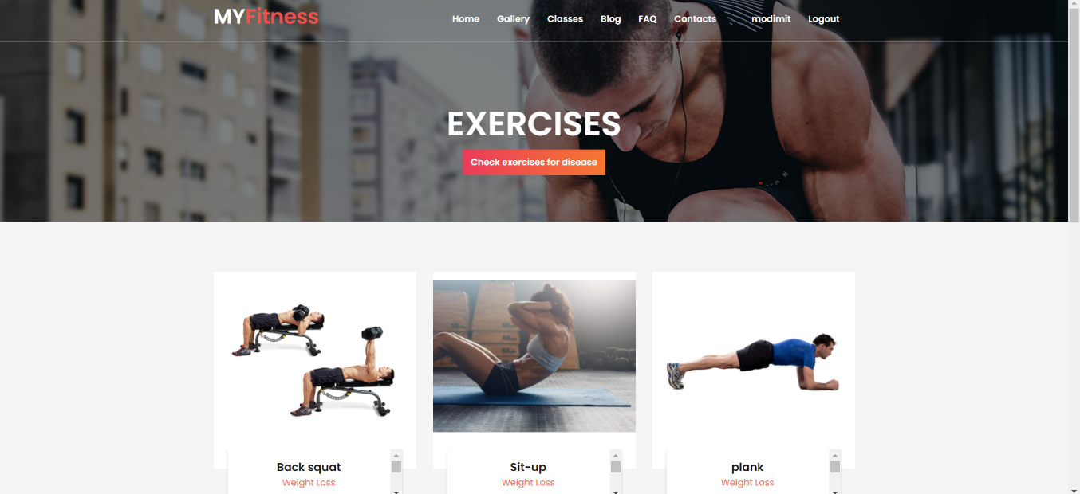

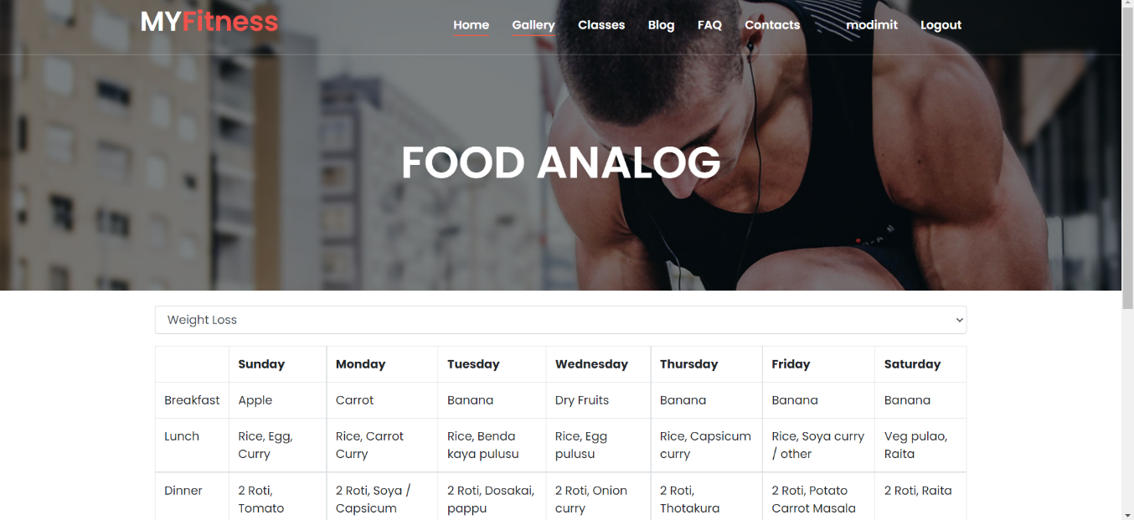**FOOD ANALOG**

**PACKAGE**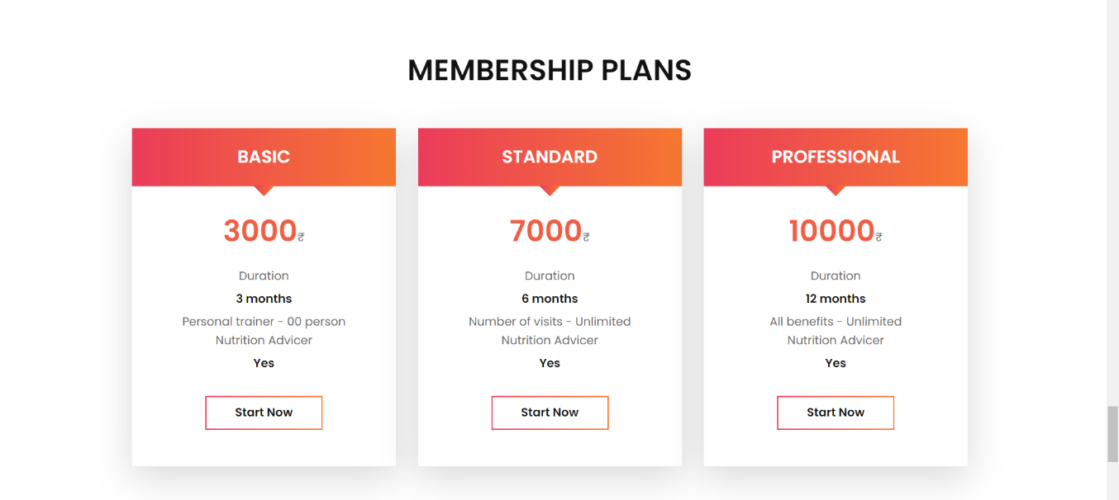

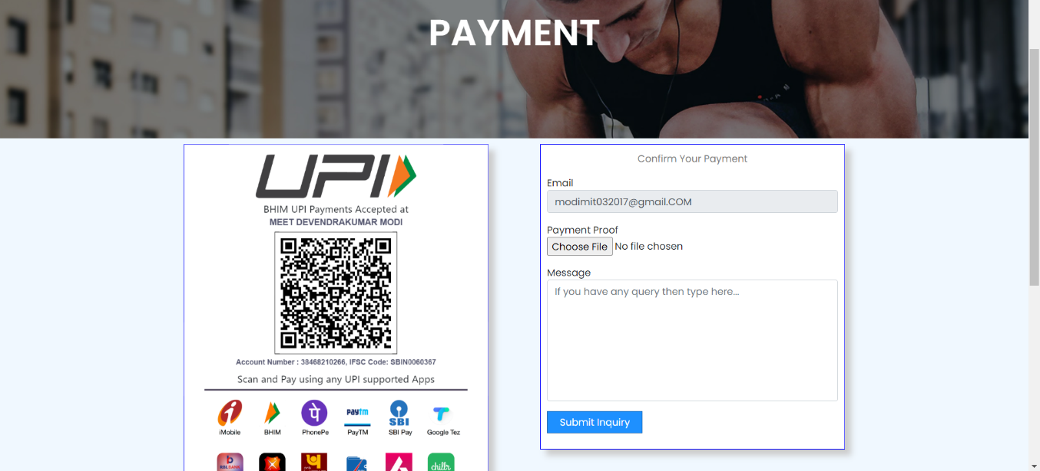**PAYMENT**

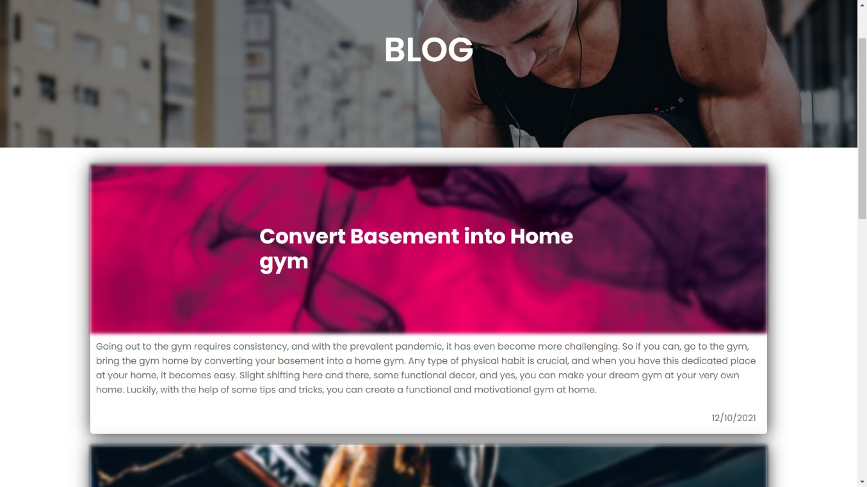

**BLOG**

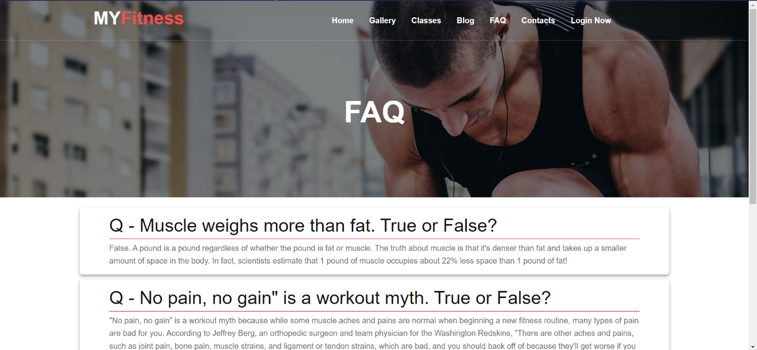**FAQ**

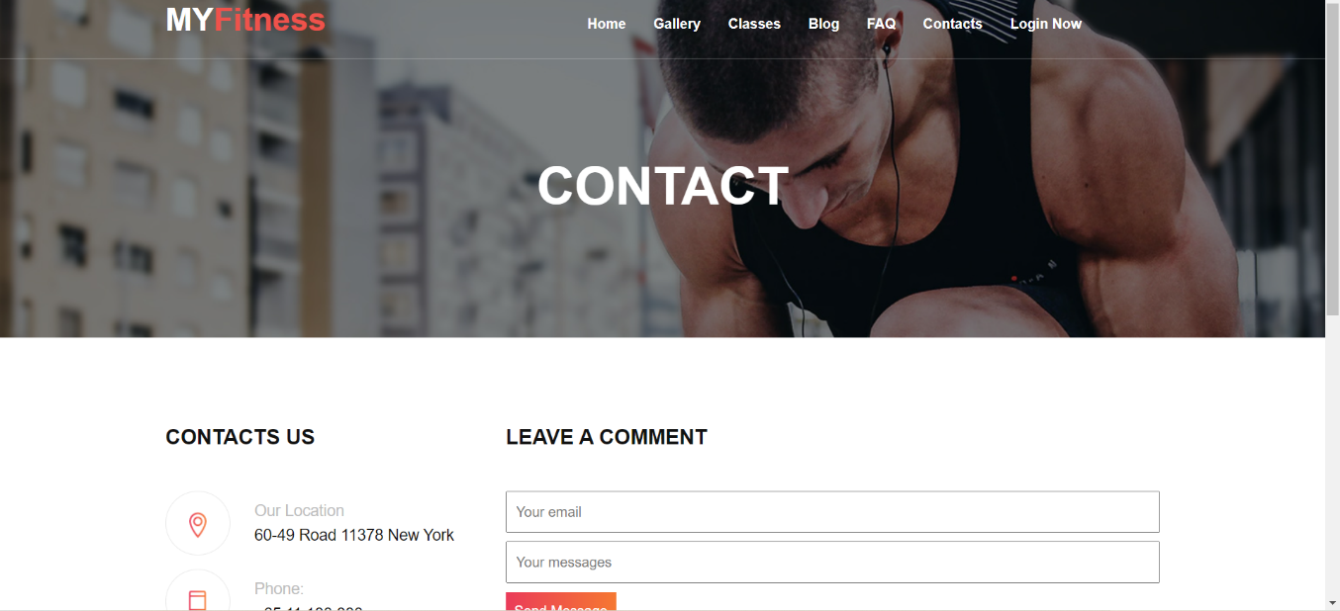**CONTACT**

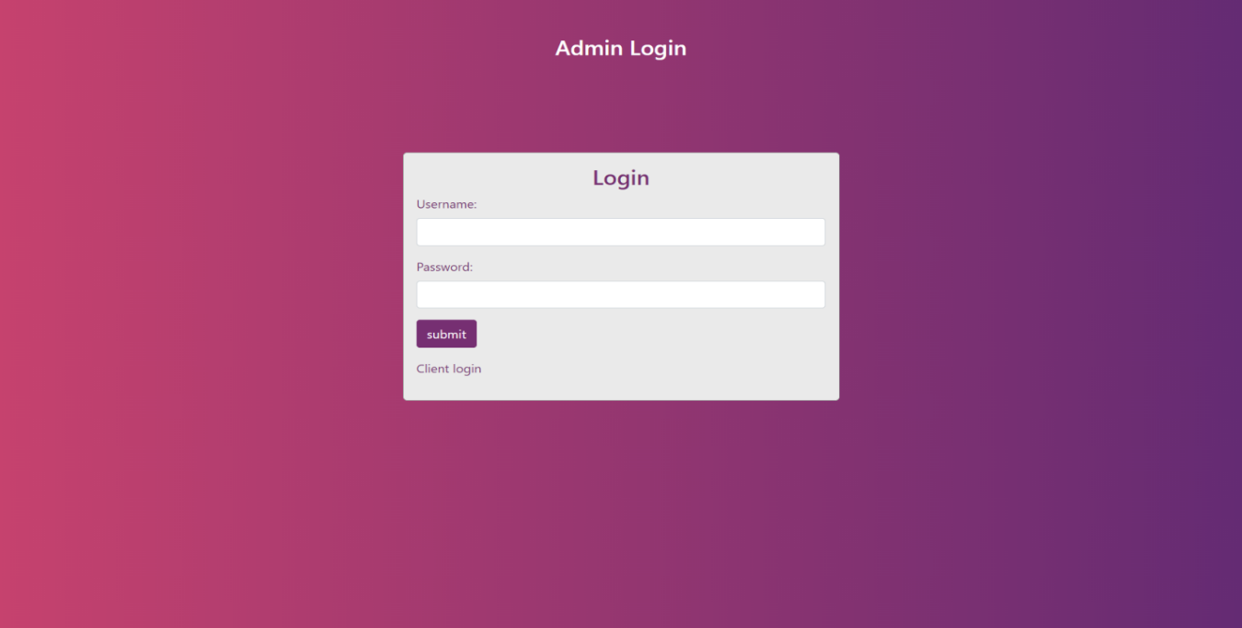

**ADMIN LOGIN**

**DASHBOARD**

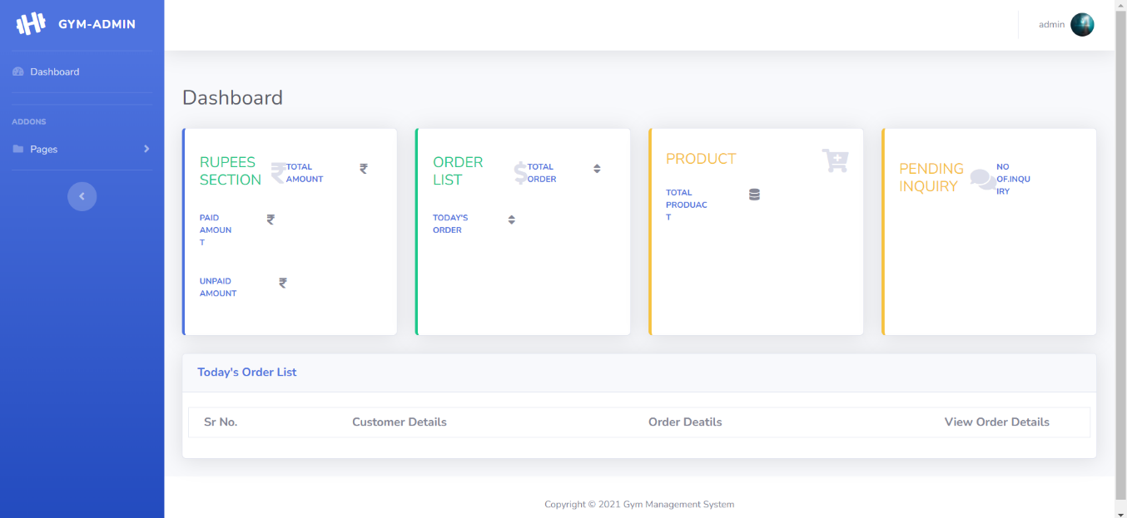

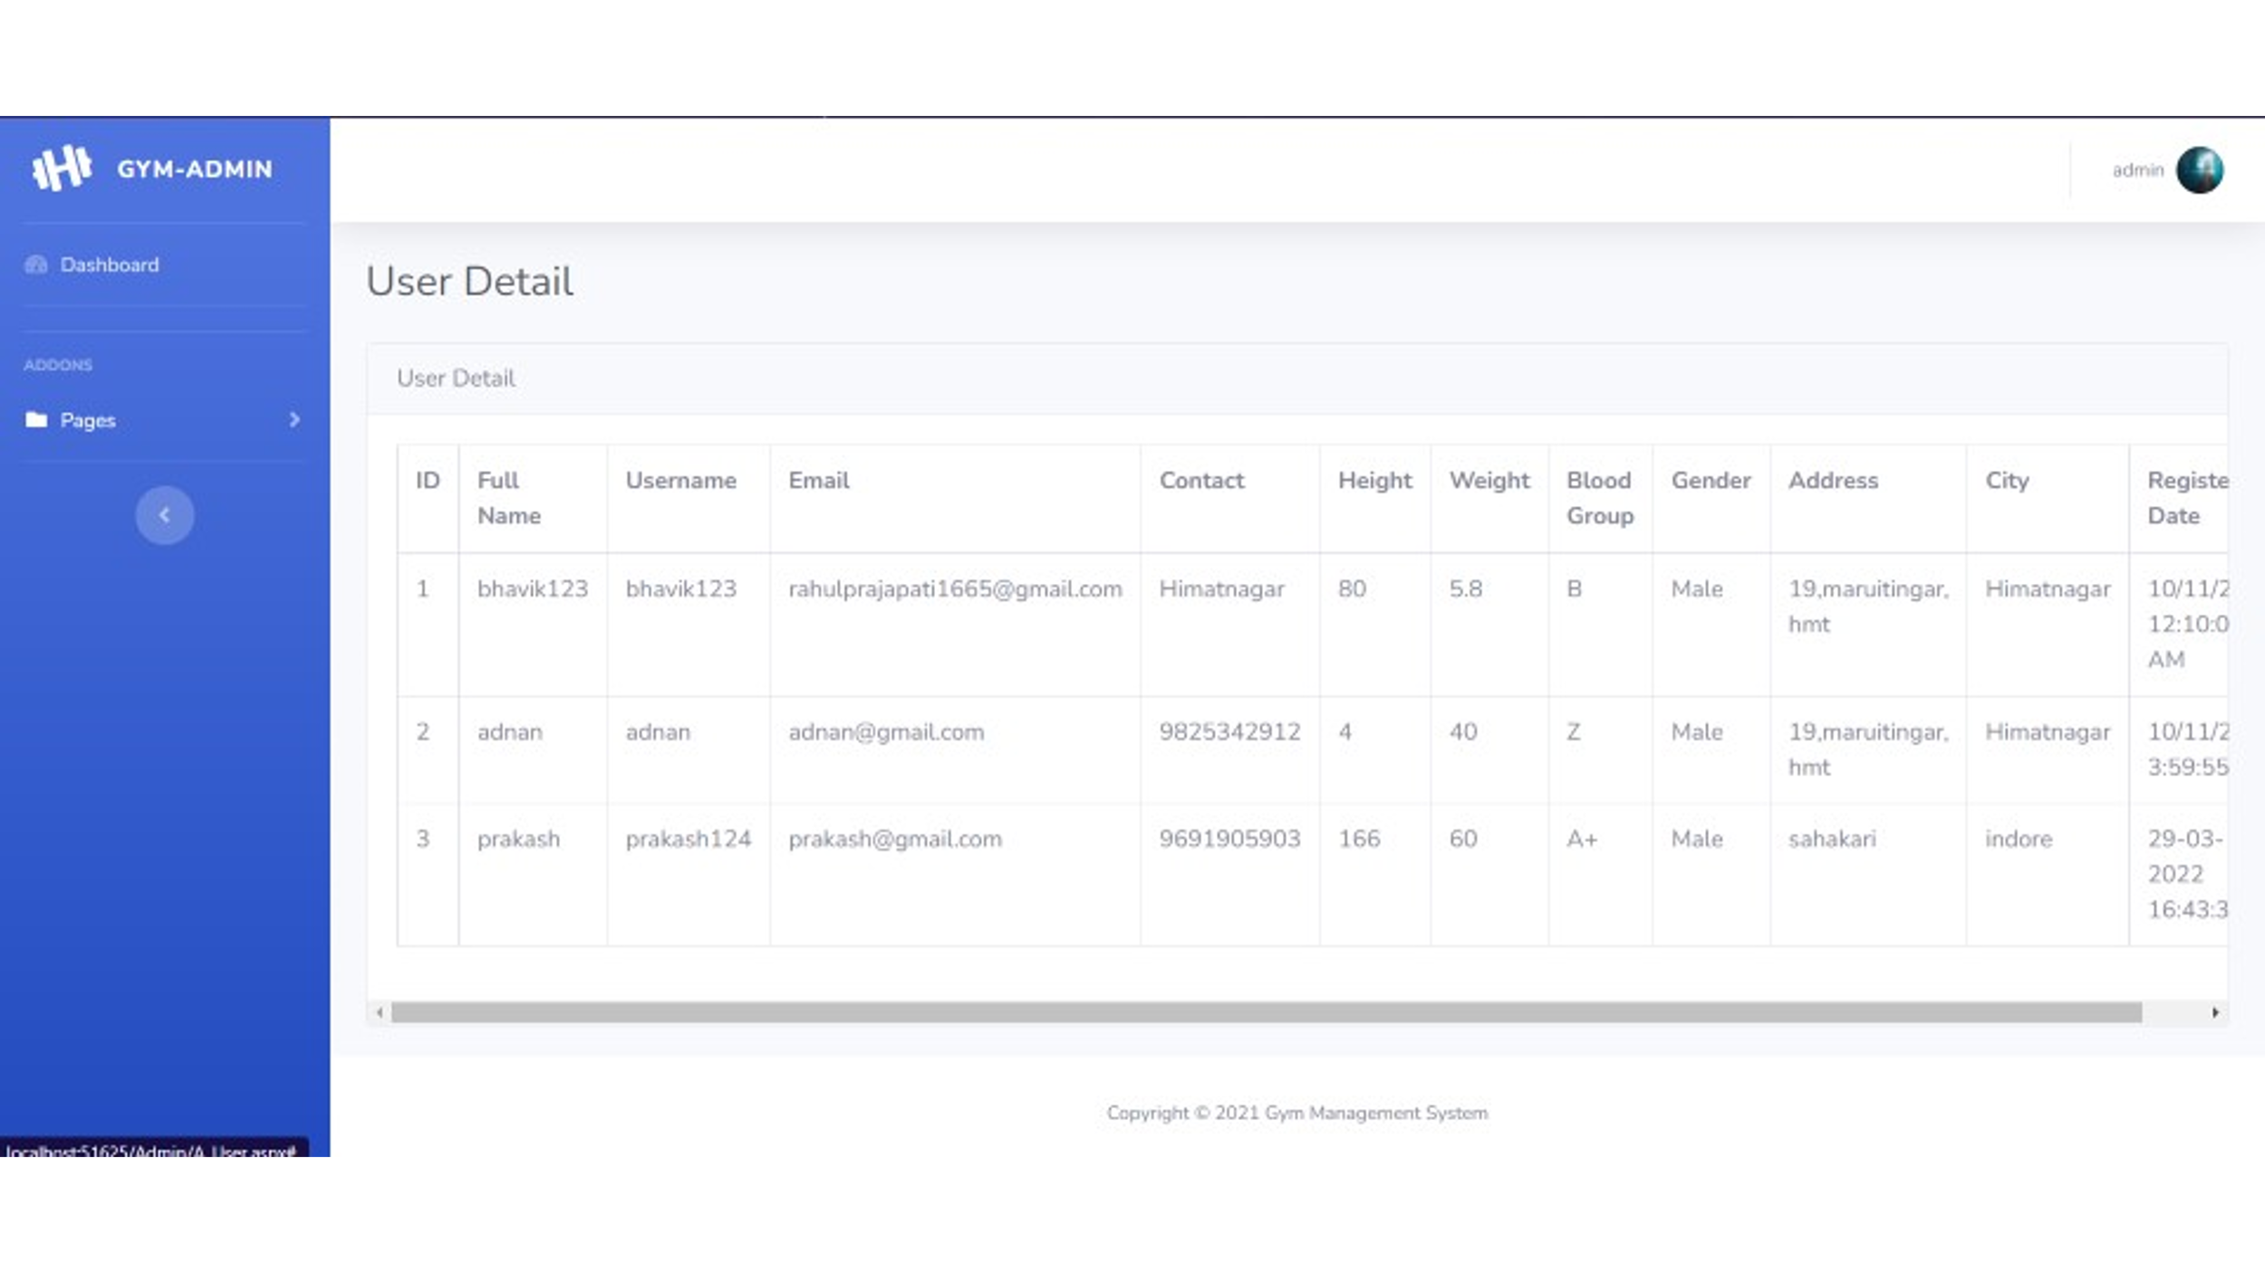**USER DETAIL**

**TRAINER DETAIL**

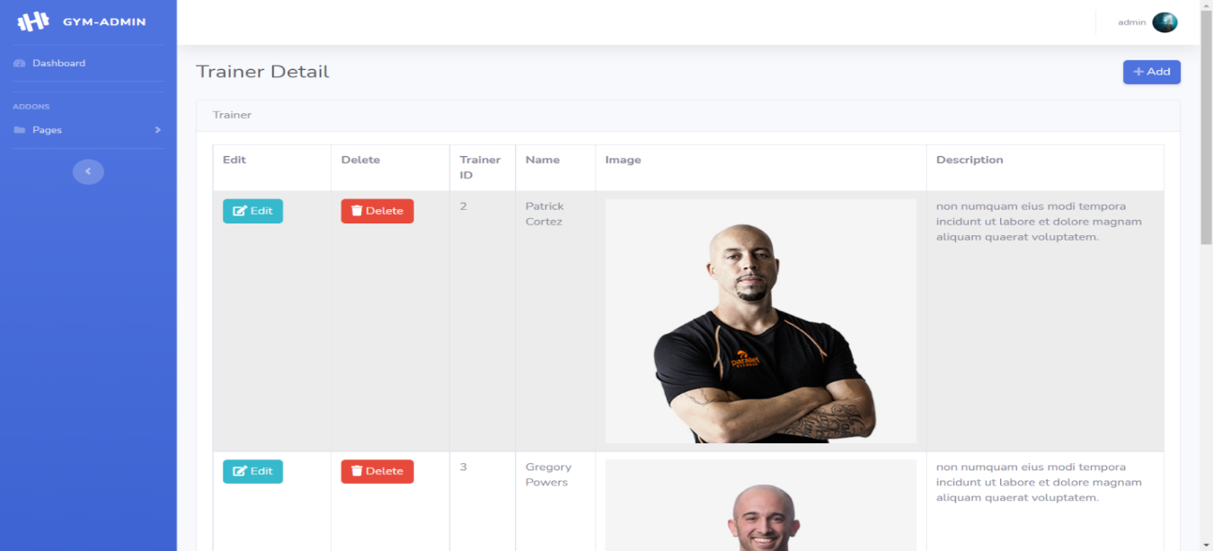

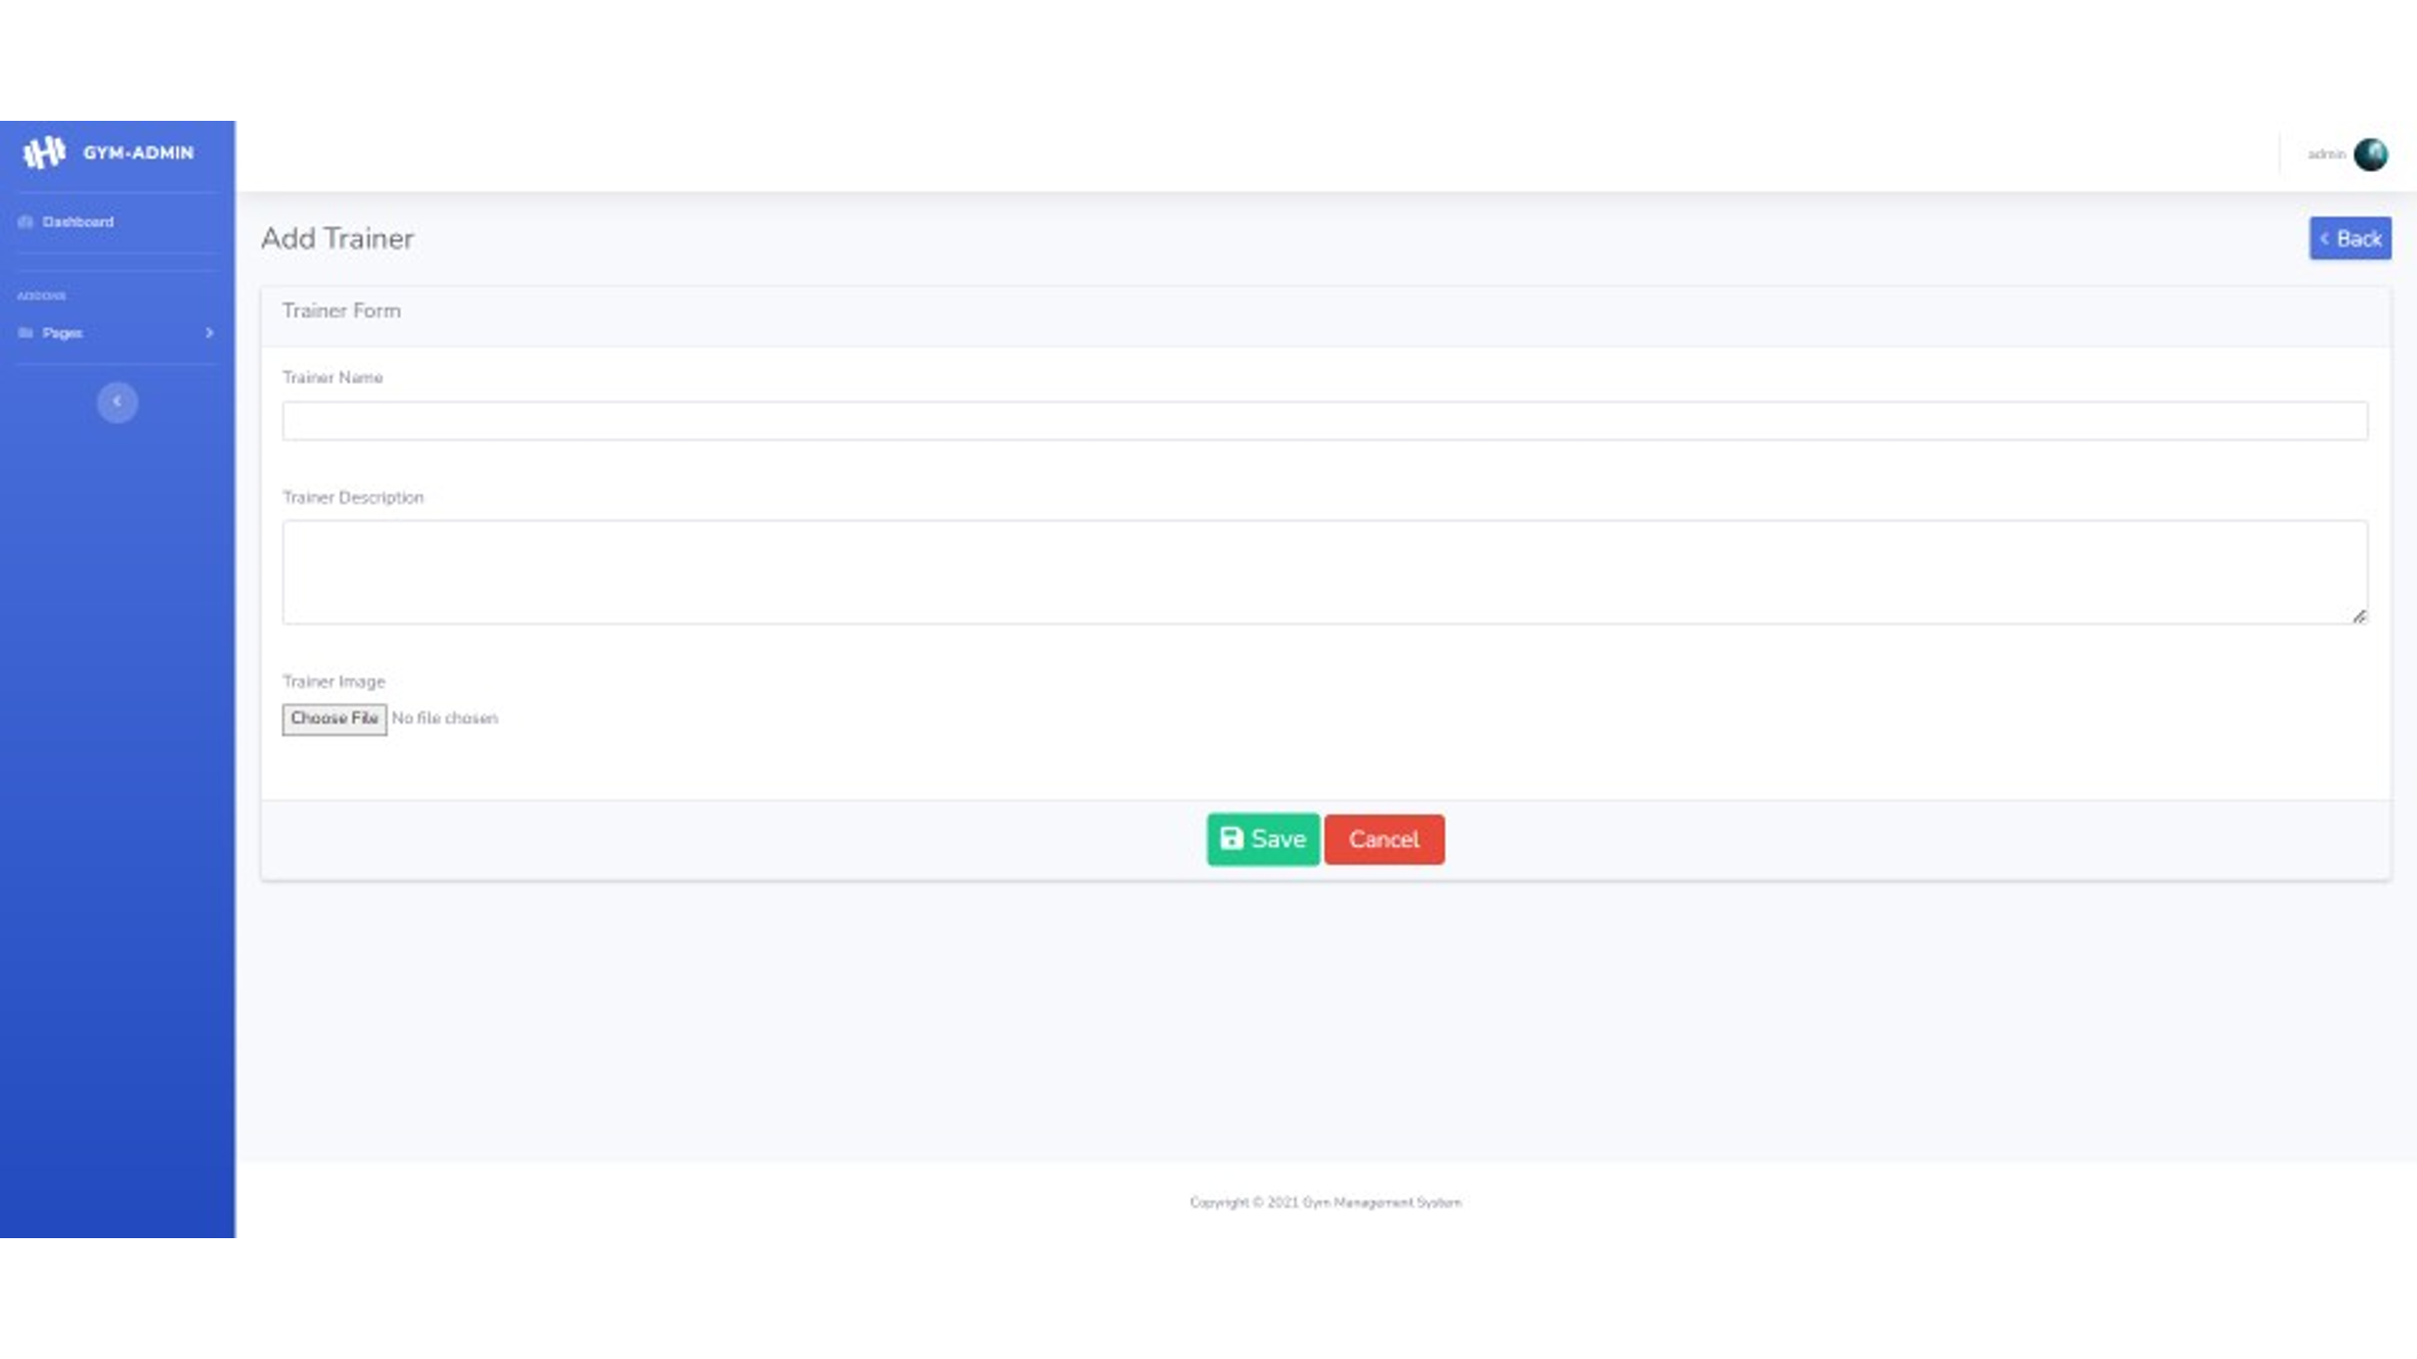

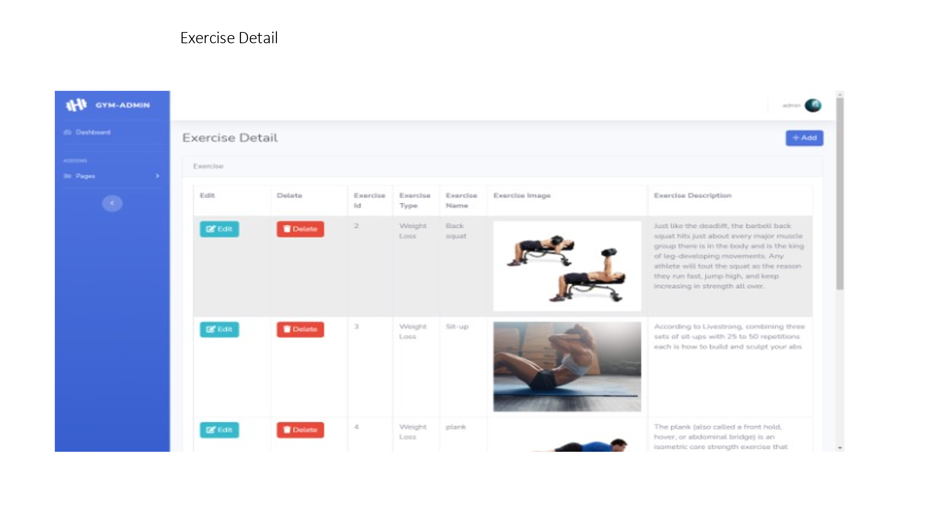**TRAINER FORM**

**EXERCISE DETAIL**

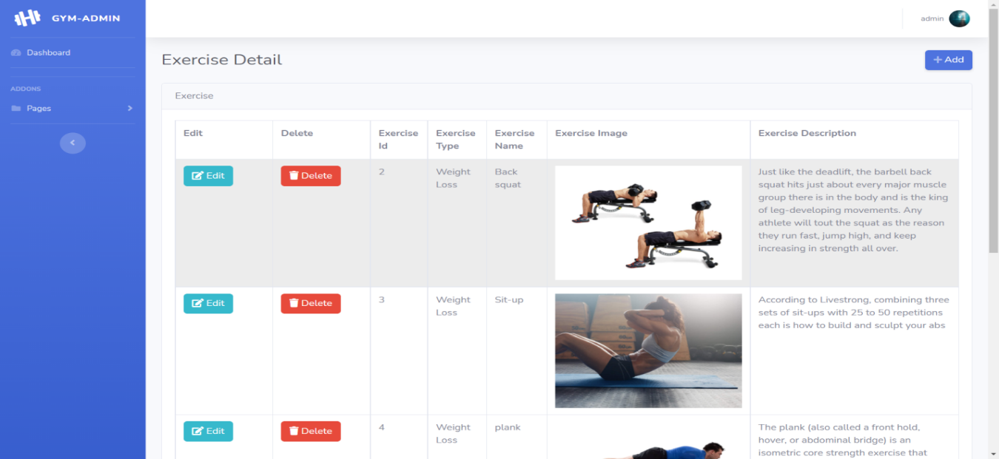

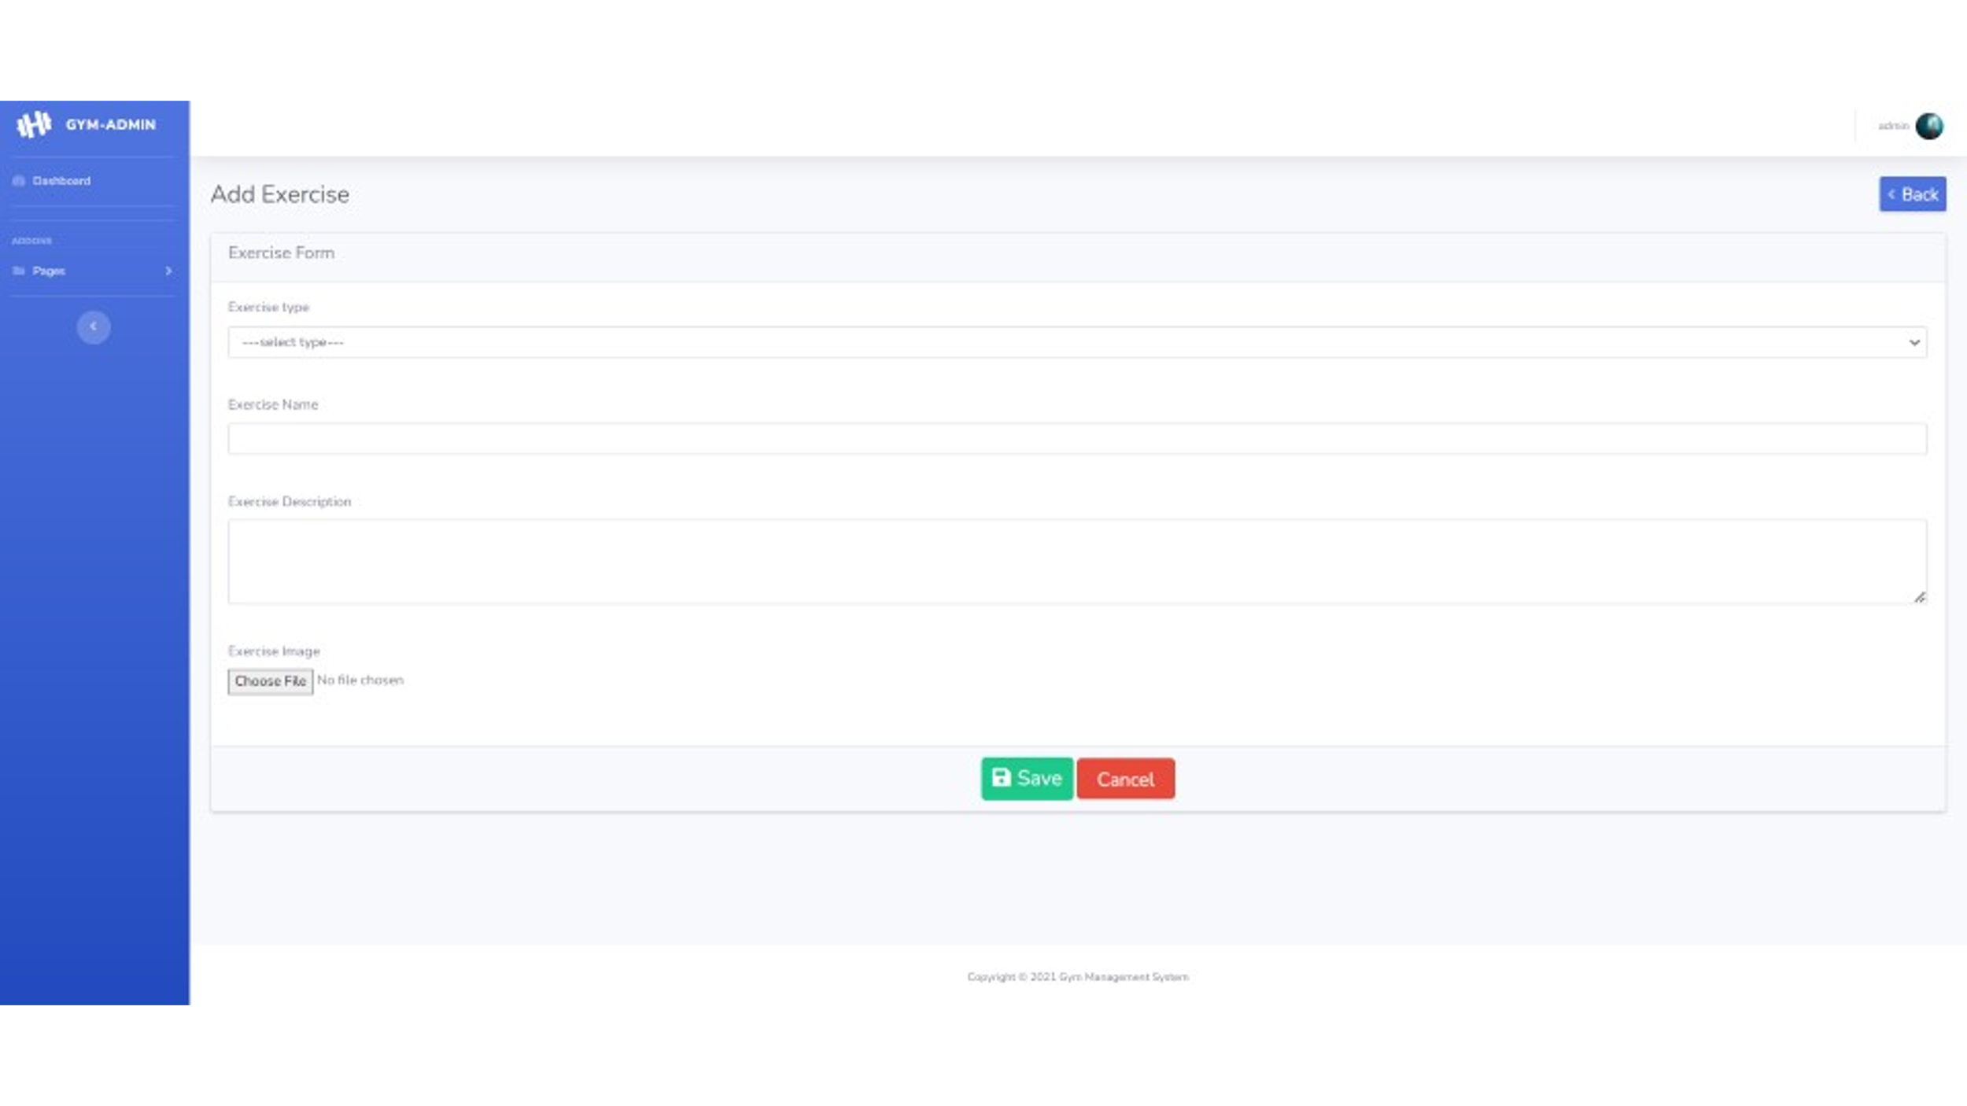**EXERCISE FORM**

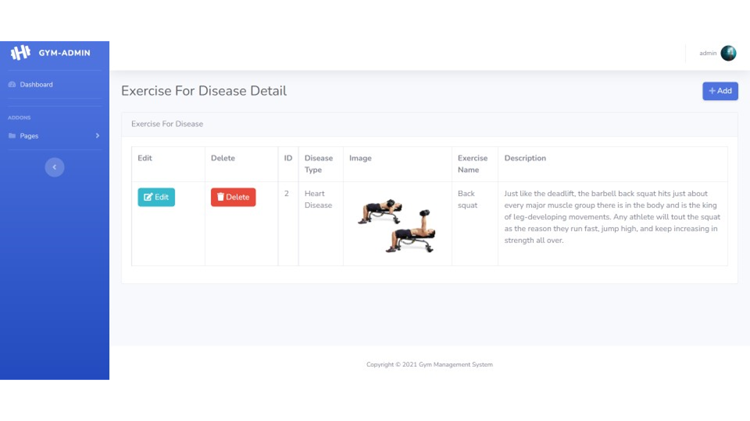

**EXERCISE FOR DISEASE DETAIL**

**EXERCISE FOR DISEASE 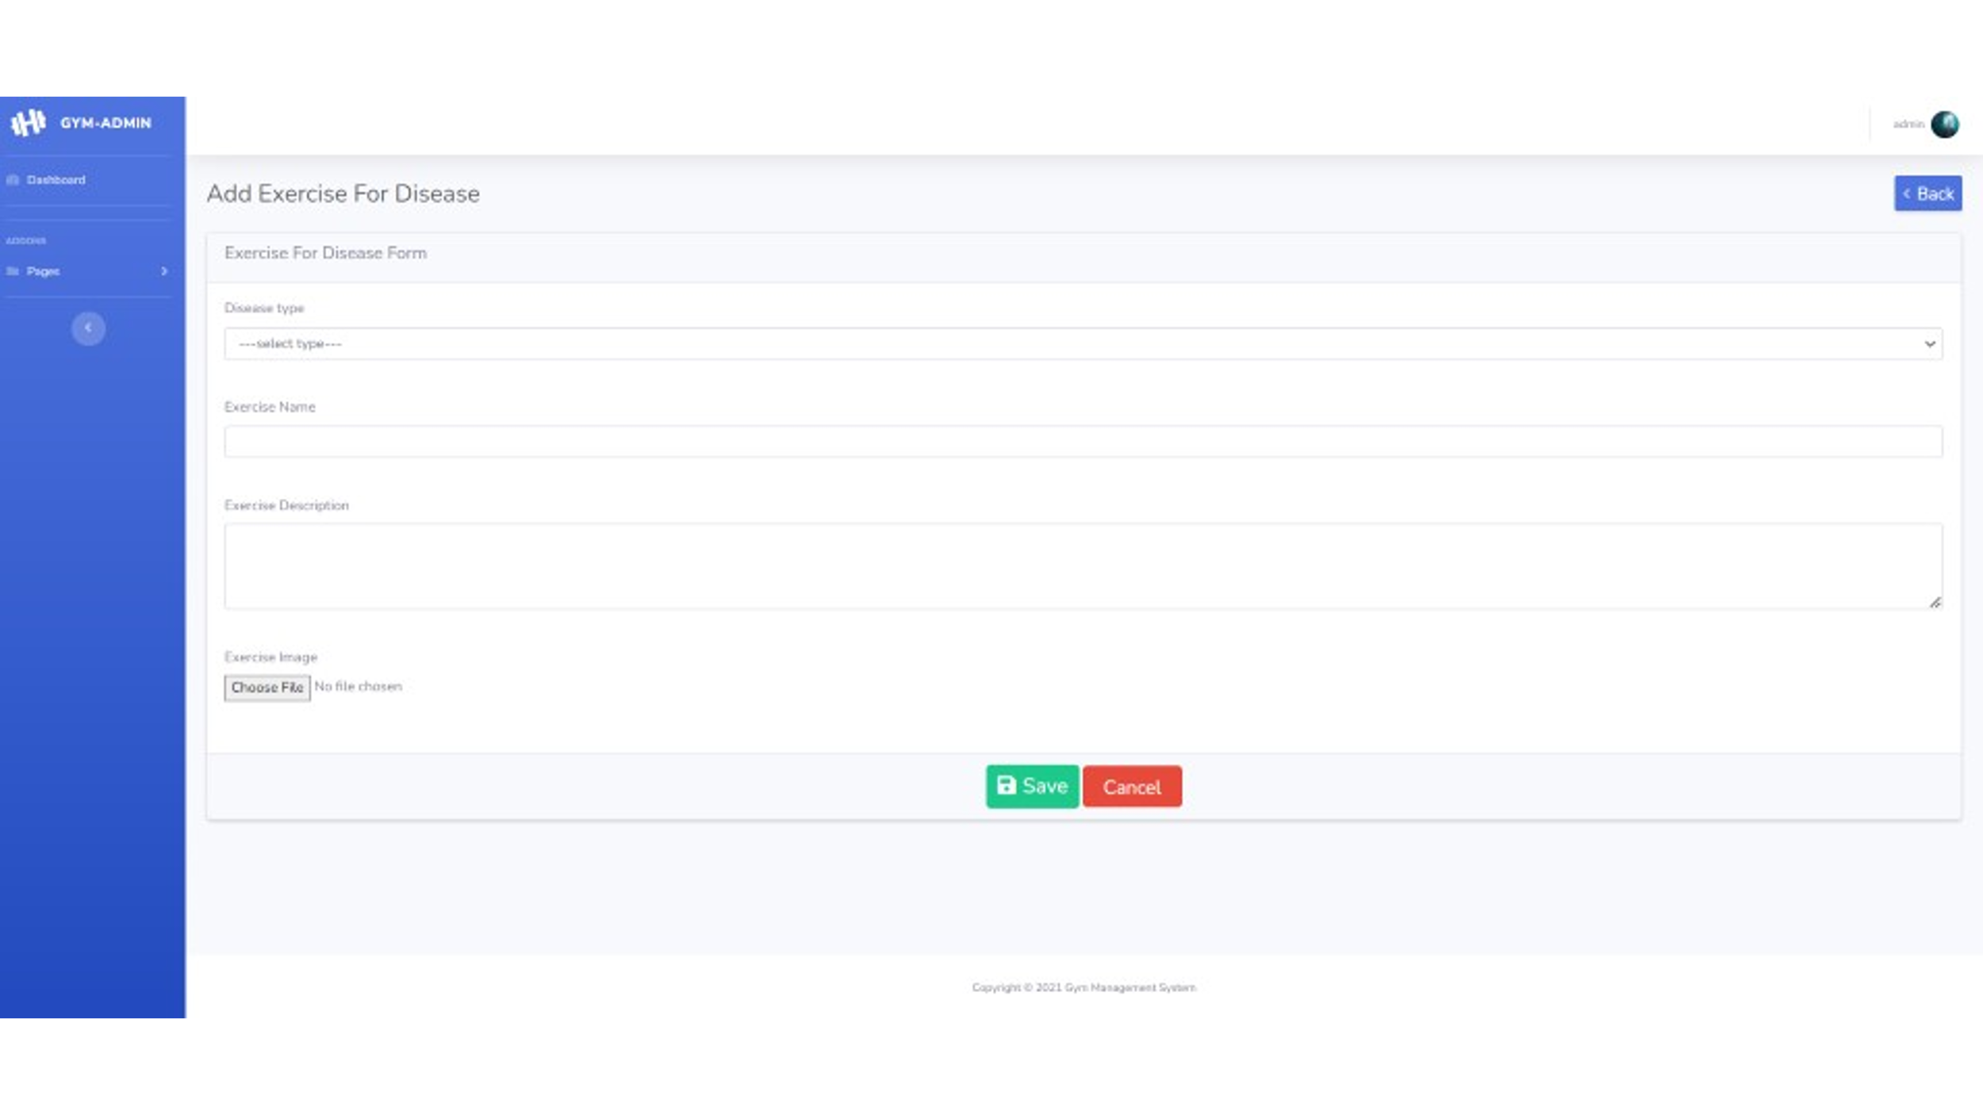FORM**

**TRAINING CHART DETAIL**

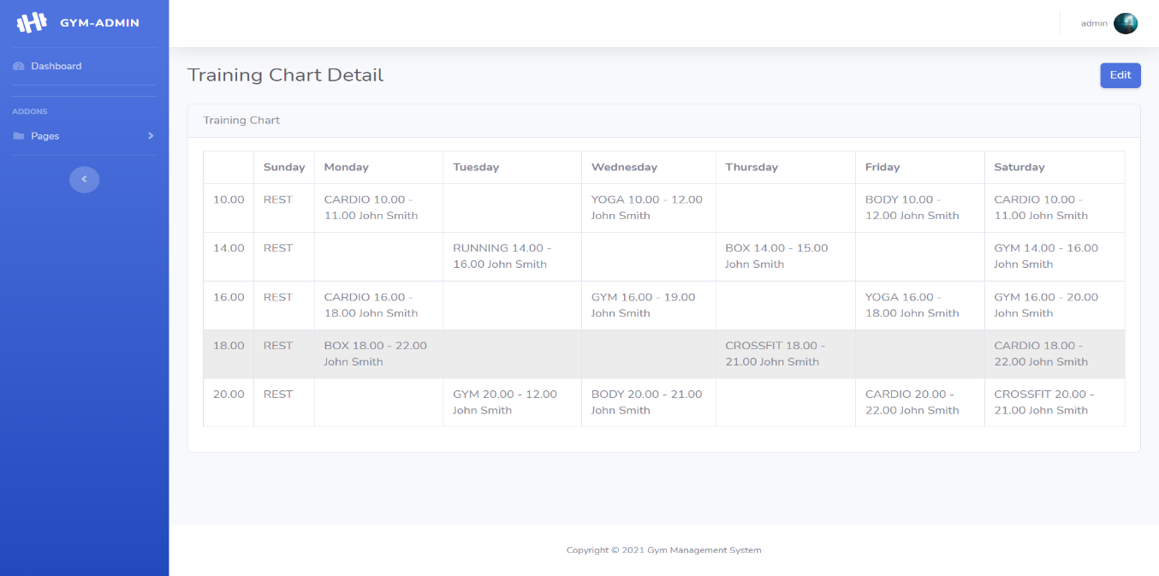

**TRAINING CHART** 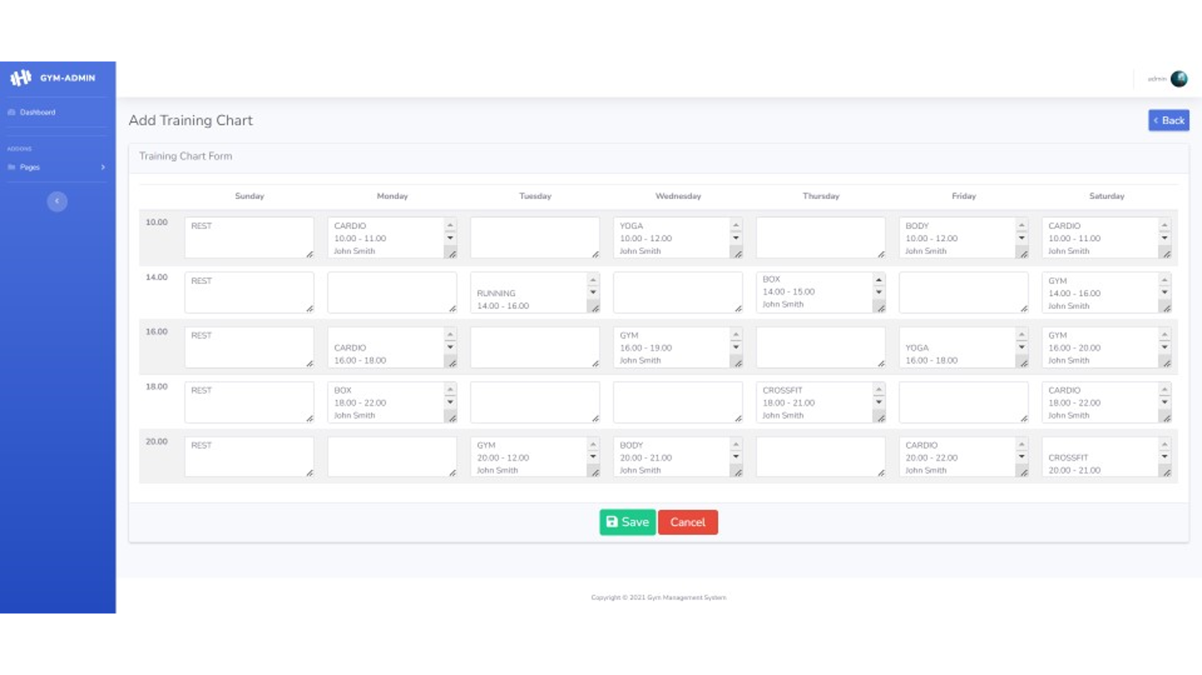**FORM**

**PACKAGE DETAIL**

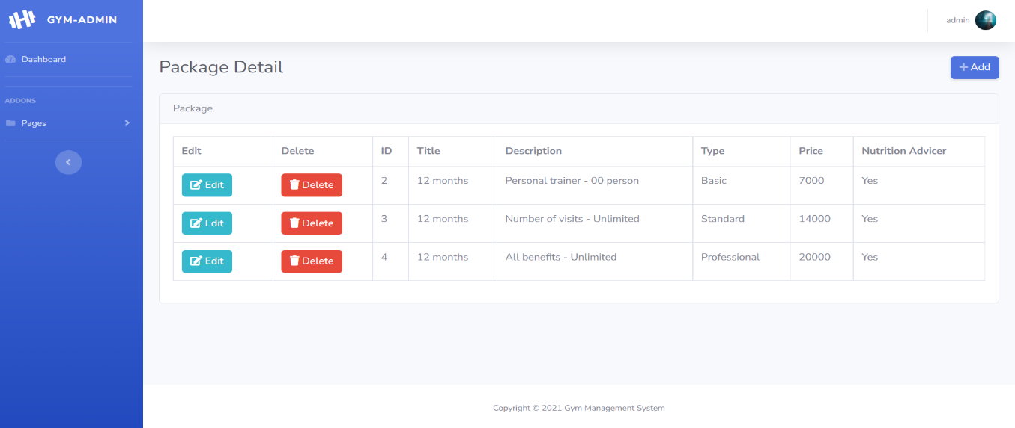

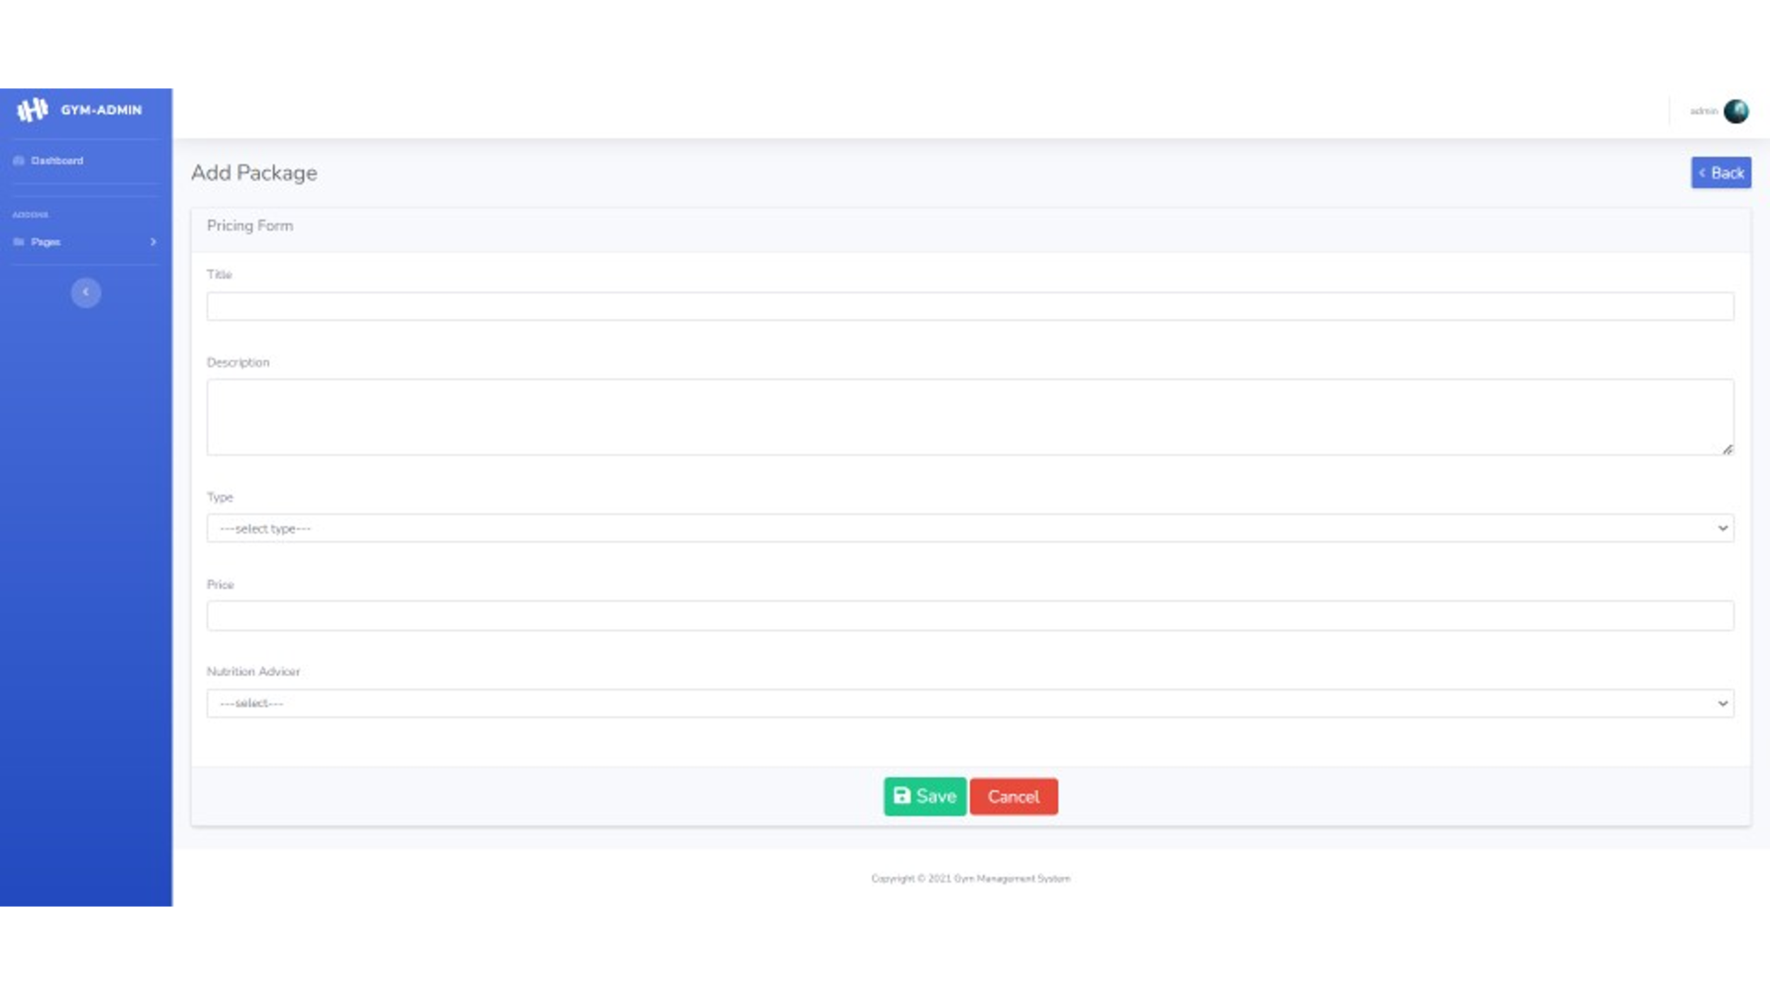

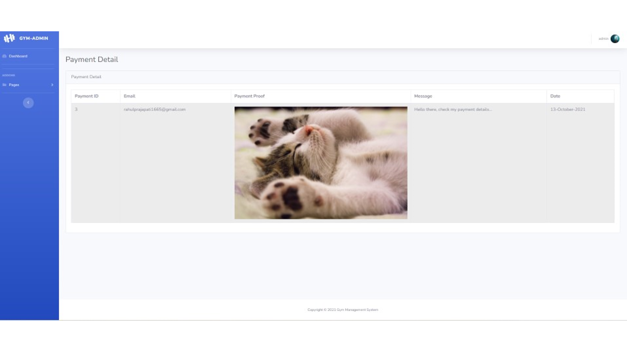

**PACKAGE FORM**

**PAYMENT DETAIL**

**BLOG DETAIL**

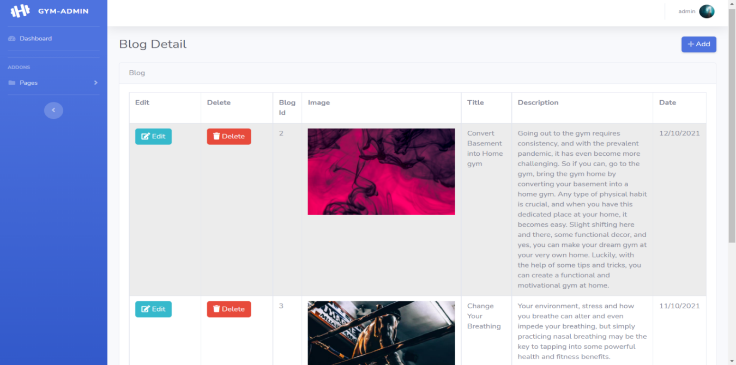

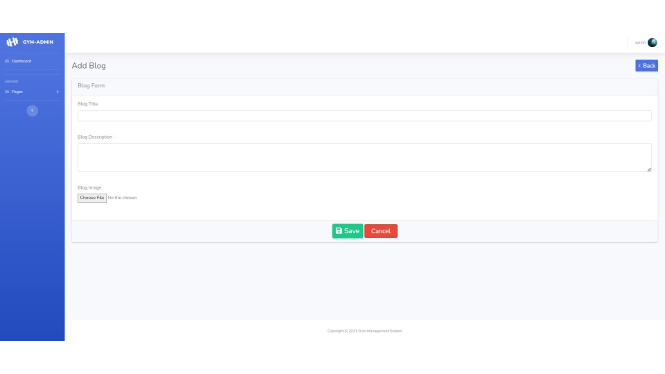

**BLOG FORM**

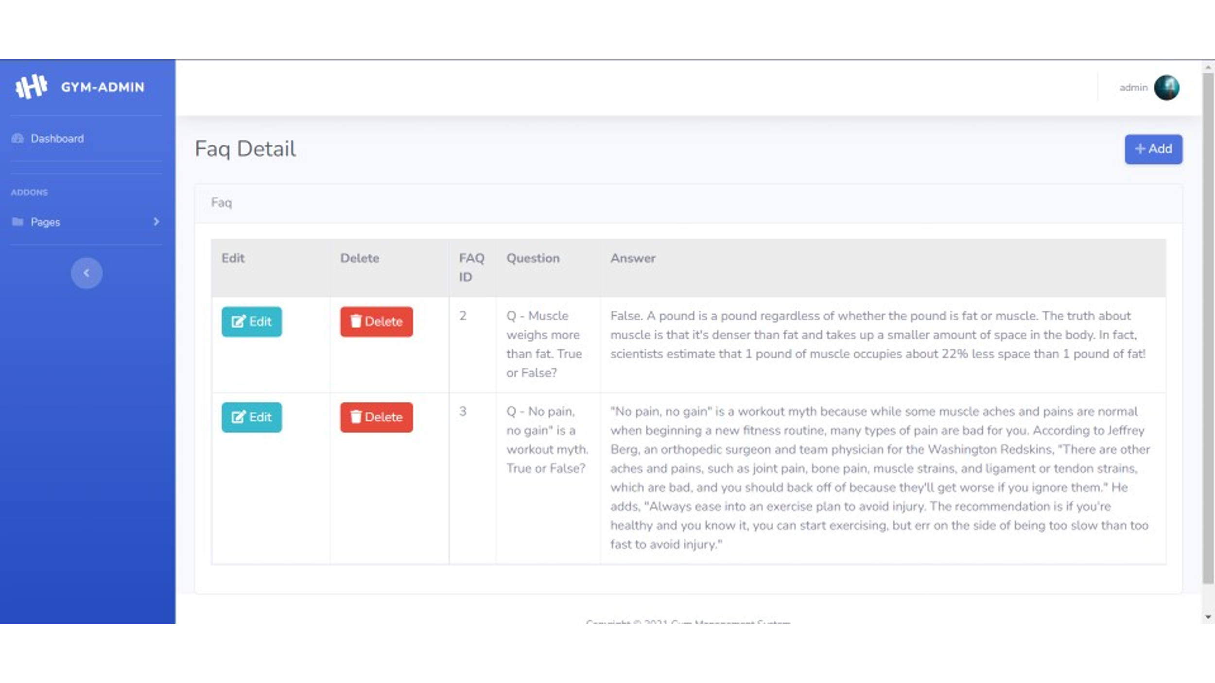**FAQ DETAIL**

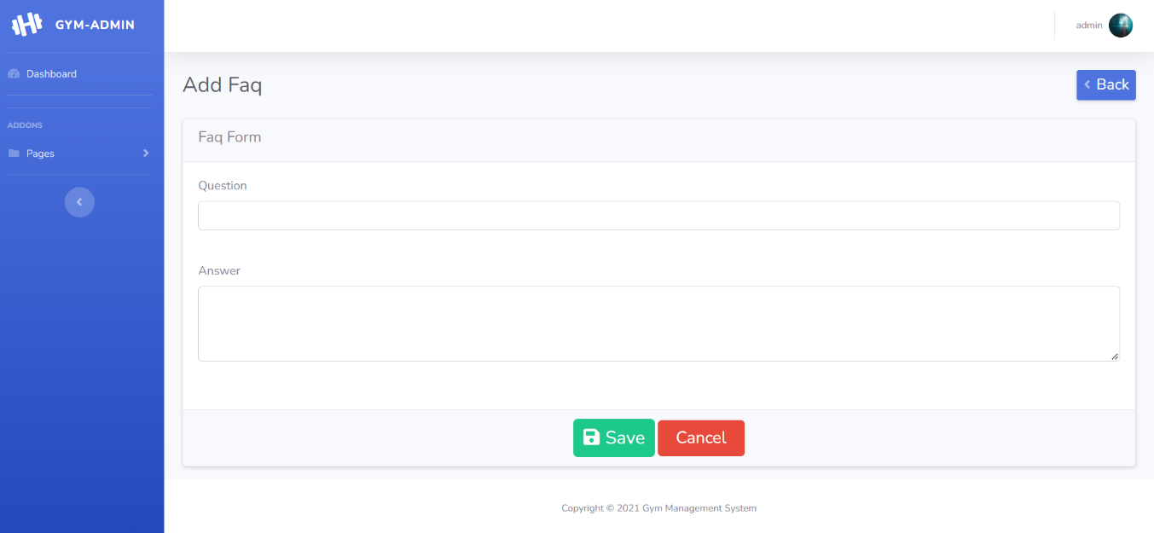**FAQ FORM**

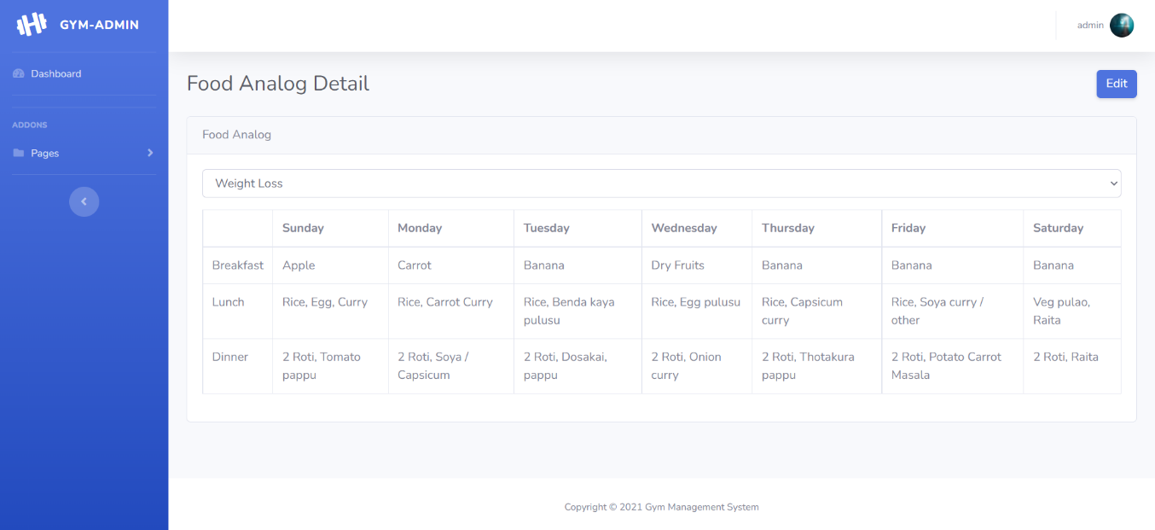**FOOD ANALOG DETAIL**

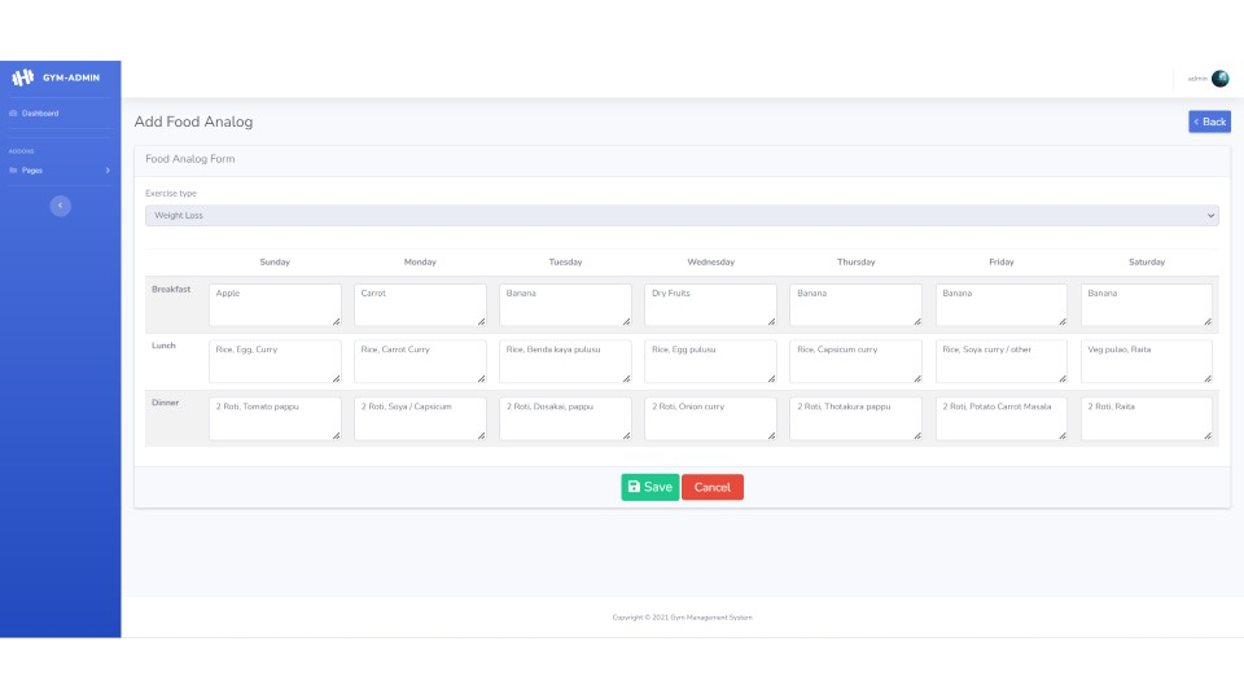**FOOD ANALOG FORM**

**CONTACT US**

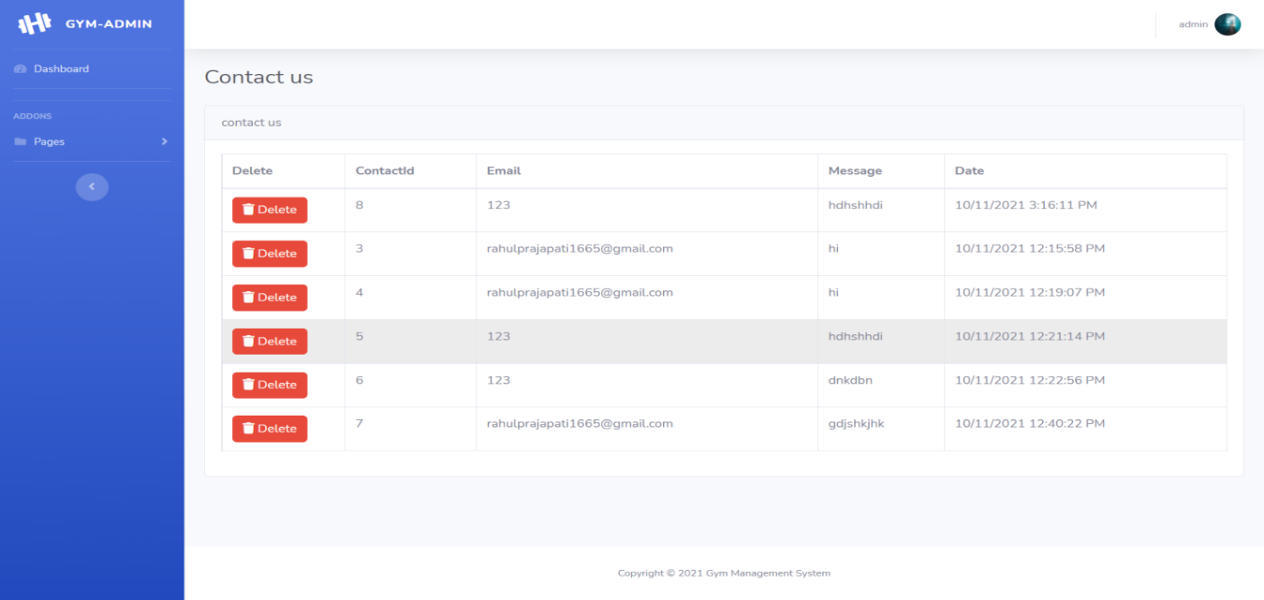

**21.TESTING**

**ADMIN SIDE**

**LOGIN MODULE**

|  |  |  |  |  |  |
| --- | --- | --- | --- | --- | --- |
| **No.** | **Test Condition** | **Description** | **Expected Result** | **Actual Result** | **Status** |
| 1 | Login | Click On Login Button Without User name & password | System not allow to login | System will display validation message | Pass |
|  |  | Click On Login Button  With invalid User name& password | System not allow to login | System will display validation message | Pass |
|  |  | Click On Login Button  With valid User name & password | System allow to login | System allow user to access Order services | Pass |

**DATA INFORMATION MODULE**

|  |  |  |  |  |  |
| --- | --- | --- | --- | --- | --- |
| **No.** | **Scenario** | **Test Condition** | **Expected Result** | **Actual Result** | **Status** |
| 1 | Submit | Click On submit Without  Input data | System display message like “input fields” | System will display validation message | Pass |
|  |  | Click On submit with  Input data | System allow to submit data | System allow to Submit | Pass |

**22.FUTURE ENHACEMENT**

* To Add Payment Gateway

* To Make Admin – User Direct Communication

* To make Function to Upload Diet Plan and Exercise Plan FILE

* To make More Categories of Exercise

* To customize GUI for Better user Experience

* To remove almost all Limitation from this Project.

**23.BIBIOLOGY(References)**

**REFERENCES BOOKS**

|  |  |  |  |
| --- | --- | --- | --- |
| **No.** | **Book Name** | **Description** | **Photo** |
| **1.** | **Asp.NET: The Complete Reference** | **Author Name:- Steven Holzner**  **Edition:- 1st**  **Publisher:- McGraw Hill Education (India) Private Limited** |  |
| **2.** | **JavaScript and JSON Essentials** | **Author Name:- Sai Srinivas Sriparasa**  **Publisher :- Packet Publishing Limited (26 October 2013)** | **C:\Users\acer\Desktop\json.jpg** |
| **3.** | **Bootstrap** | **Author Name:- Jake Spurlock**  **Edition:- 1st**  **Publisher:- O'Reilly Media** | **http://ecx.images-amazon.com/images/I/51a61FqXXFL._SX258_BO1,204,203,200_.jpg** |

**24.WEB REFERENCES**

* Web Development learnt From YouTube Channel : [Stack Overflow - Where Developers Learn, Share, & Build Careers](https://stackoverflow.com/?form=MY01SV&OCID=MY01SV)
* Wamp Server Downloaded From :[Download Wampserver 64bits - WampServer](https://www.wampserver.com/en/download-wampserver-64bits/)
* Error and Doubt Solve : [**StackOverflow**](https://stackoverflow.com/) and [**w3school**](https://w3schools.com/)